|  |  |  |
| --- | --- | --- |
|  | **TRƯỜNG ĐẠI HỌC FPT**  **TRUNG TÂM ĐÀO TẠO LẬP TRÌNH VIÊN QUỐC TẾ**  **FPT-APTECH** | AptechIDCE160511VAptechIDCE160511VAptechIDCE160511VAptechIDCE160511V |

East2West

Tài liệu Thiết kế - Học kỳ 4

|  |  |  |  |
| --- | --- | --- | --- |
| **Giáo viên hướng dẫn:** | **Pham Cong Thanh** | | |
| **Lớp:** | GC0761 | | |
| **Tên nhóm** | 04 | | |
| **Tên thành viên trong nhóm:** | Tên đầy đủ | | Mã số Sinh viên |
|  | 1. | Bui Ngoc Quang Anh | GC60131 |
|  | 2. | Nguyen Anh Tuan | GC60137 |
|  | 3. | Hoang Dinh Manh | GC60134 |
|  | 4. |  |  |
|  |  |  |  |

Review 1

**I.Introduction**

East2West Tours and Travels is a young and dynamic company run by dedicated professional’s committed to providing the highest standards of service to the travel industry. We place great emphasis on personalized service, meticulous attention to detail, innovative itineraries and excellent customer care.

However, over the years, there have been few difficult situations or queries, which we have not been able to solve and look forward to improve upon in the future. We are on call, at your service, 7 days a week. Our rates are highly competitive, and if you are seeking a travel agency who can not only provide top quality service, but can also anticipate and fully understand your needs, then look no further.

**II. Problem Definition**

***1 .Problem Abstraction***

- An application should be created that will provide the following functions:

+ Query the database and display packages according to the criteria specified by the customer

+ Book customer for the chosen package tour

+ Query the database and display cars that fit in the specifications provided by the customer

+ Rent a car to a customer

+ Find and display detailed information about the hotels in a city

+ Find and display information about the flights to a city

+ Cancel package bookings and car rentals and calculate the appropriate refund

+ Apart from this, help in ad hoc report generation.

***2. Development Environment***

- Hardware

+ Pentium IV 1.80 GHz

+ Hard disk requirement : minimum 5GB

+ 512 Megabytes of Ram or Higher

- Software

+ Jboss Server

+ Internet Explorer 8

+ Microsoft SQL Server 2008

+ NetBeans IDE 6.9.1 , JDK 1.6

+ Microsoft Word 2007

+ Windows 7 or higher

**III. Requirements and Business Flow**

***1. Customer Requirement Specification***

***1.1 Package Tours***

- Search the database and display detailed information about the Package tours that are available according to the parameters provided by the customer.

- Book the customer for the selected Package tour.

- Cancel the booking as and when required.

***1.2 Car Rentals***

- Search the database and display the available car models , car types and their cost according to the parameters given by the customer. The parameters could be car model, type, air-conditioning required, driver required, seating capacity, pickup date or drop off date.

- Book the car that the customer has selected.

- Cancel the booking as and when required.

***1.3 Information Desk***

- Search the database and display the hotels that are available in the city ,and within the price range specified by the customer.

- Search the database and display detailed information about the flights that are available to the destination specified by the customer and that leave from the departure airport specified by the customer.

***1.4 Sales Analysis***

- Perform sales analysis on the car rental service by calculating how much revenue is generated based on the following factors:

+ Car model

+ Car type

+ Income range of customers

+ Rental cost

+ Air – conditioned cars

+ Non air – conditioned cars

+ Season

- Perform sales analysis on the Package Tour service by calculating how much revenue is generated based on the following factors:

+ Package duration

+ Package type

+ Package cost

+ Income range of customers

+ Group type of customers

+ Season

***2. Functional Requirement Specification***

***2.1 Guest***

- Guest can search tour but can’t book a tour

***2.2 Guest can register and become a customer***

***2.2.1 Description***

- The system provide a page to allow guest create their account to become a customer with the following information:

- Username

- Password

- Full Name

- Gender

- Email

- Nationality

- Address

- Phone

***2.2.2 Functional Requirements***

REQ-01 Guest must provides Username, Password,Full Name,Gender ,Email,Nationalty , Address, Phone to create an account and become a customer

REQ-02 Email and Username are unique

***2.3 Guest can login as a customer***

***2.3.1 Description***

- The system must provide a page to allow guest login as a customer.

***2.3.2 Functional Requirements***

REQ-01 Guest must provide Username and Password to login into the website

REQ-02 System must distinguish the type of account to display pages which the account can view and access

REQ-03 Customer can only access the pages they have permission

***2.4 Management of Customer***

***2.4.1 Description***

- System must provides of Customer a management page

***2.4.2 Function requirements***

REQ-01 Customers can modify their profile

***2.5 Customer or Guest can search for a Package tour***

***2.5.1 Description***

- Customer or Guest provide the information down here for searching :

+ Location

**2.5.2 Function requirements**

REQ-01 Customer Guest can search the locaion of the tour with or without price or start date

**2.6 Customer book Tour**

**2.6.1 Description**

- The system provides 2 pages,there are The Tours and The Tours Cart

- After customer have found the Package Tour that match to the parameters which had been provide,the customer can book the tour

- The Tours will show the tour information and customer have to fill the number of participants.This is the information of Tour information when book :

+ Tour location

+ Tour duration

+ Tour start date

+ Tour price

+ Tour participants

+ Tour status

- After the customer have book,website will automaticaly forward to Tours Cart page

- The Tours Cart will let the customer confirm the tour or cancel the tour before put the information into database after the database have checked the information of the tour

**2.6.2 Function requirements**

REQ-01 The Tours must be available at that time and not full of customers

REQ-02 Customer click the book button and the tour information will be put into the Tours Cart

REQ-03 Customer can continue booking or confirm the tour or also cancel the tour after have read the policy

REQ-03 The Tours Cart will put all of Tours Information into database Order after the customer confirm

**2.10 Create Tour**

**2.10.1 Description**

- The system providers a page which can create a new tour with information down here:

+ Tour Name

+ Start Date

+ End Date

+ Start Location

+ End Location

+ Quantity Min

+ Quantity Max

+ Current tour quantity

+ Price

**2.10.2 Function requirements**

REQ-01 Admin need insert to all field at Create Tour page  
 REQ-02 All field cannot blank

REQ-03 When admin click Create Tour, go to Add Schedule Tour page

**2.11 Add Schedule**

**2.11.1 Description**

- The system providers a page which can create information of the schedule tour

+ Description

+ Image

**2.11.2 Function requirements**

REQ-01 Admin need insert to text area all information of the schedule of the tour  
 REQ-02 Text area cannot blank

REQ-03 When admin click Done, save all to Database

***2.12 Report Book Tour***

***2.12.1 Description***

- The system also provides a page that view top 10 of tours which was booked the most

***2.12.2 Function Description***

REQ-01 The information of top 10 tours will be show after was calculate

**2.12 Show All Tour**

**2.12.1 Description**

- The system providers a page which can create information of the schedule tour

+ Description

+ Image

**2.12.2 Function requirements**

REQ-01 Admin need insert to text area all information of the schedule of the tour  
 REQ-02 Text area cannot blank

REQ-03 When admin click Done, save all to Database

***2.12 Report Book Tour***

***2.12.1 Description***

- The system also provides a page that view top 10 of tours which was booked the most

***2.12.2 Function Description***

REQ-01 The information of top 10 tours will be show after was calculate

***2.13 Add car***

***2.13.1Description***

- The system provide a page to add new car to database

+ Model

+ Type

+ Seating Capacity

+ Driver required/not required

+ Air-conditioner required/not required

+ Pick-up date and Drop-off date

+ Description

+ Image

+ Stock quantity

+ Price

***2.13.2 Function Description***

REQ-01 Admin need to insert all information into textfields

REQ-02 When submit, all information will be saved into the database

***2.14 Search car***

***2.14.1 Description***

System provide a pages to search for car

+ Model

+ Type

+ Seating capacity

+ Air-conditioner required/not required

+ Price range

***2.14.2 Function requirements***

REQ-01 User provides information about the car they want(model, number of seat, etc)

REQ-02 System will provide the cars that match the criterias

REQ-03 User can view car's details

REQ-04 Admin can view/update car's details or delete car

***2.15 Update car***

***2.15.1 Description***

System provide a page for admin to update car's details

+ Model

+ Type

+ Seating Capacity

+ Driver required/not required

+ Air-conditioner required/not required

+ Pick-up date and Drop-off date

+ Description

+ Image

+ Stock quantity

+ Price

***2.15.2 Function requirements***

REQ-01 Admin edit car's detail

REQ-02 After clicking submit, car's detail will be update to the database

***2.16 Delete car***

***2.16.1 Description***

- System will provide a page for admin to delete car

***2.16.2 Function requirement***

REQ-01 When admin click delete, he/she will be promt for comfirmation

REQ-02 When admin confirm, the car will be set to disable in the database

REQ-03 A confirmation of success or failure will be present to the admin

***2.17 View car's details***

***2.17.1 Description***

- System will provide a page for user to view car's details

+ Model

+ Type

+ Seating Capacity

+ Driver required/not required

+ Air-conditioner required/not required

+ Pick-up date and Drop-off date

+ Description

+ Image

+ Stock quantity (Admin only)

+ Quantity left

+ Price

***2.17.2 Function requirement***

REQ-01 When description button is click, user will be redirect to a page contain all car's information

REQ-02 User can click book button to book that car

REQ-03 Admin can update car's details or delete that car

***2.18 Book car***

***2.18.1 Description***

- System provide a pages to book car

+ Quantity

+ Do you want a driver?

+ Pickup date

+ Drop off date

***2.18.2 Function requirements***

REQ-01 User provide booking information

REQ-02 When user click add to cart, he/she will be redirect to shopping cart page

***2.19 Car shopping cart***

***2.19.1 Description***

- System provide a pages to review all items that user had book

+ Quantity

+ Do you want a driver?

+ Pickup date

+ Drop off date

+ Total cost

Order cost

***2.19.2 Function requirements***

REQ-01 User can edit booking details and click update

REQ-02 User can remove any item from the shopping cart

REQ-03 When user click check out, he/she will be redirect to the checkout page

***2.20 Car checkout***

***2.20.1 Description***

System provide a pages to review all items in the shopping cart

+ Quantity

+ Do you want a driver?

+ Pickup date

+ Drop off date

+ Total cost

+ Order cost

***2.20.2 Function requirements***

REQ-01 System will show billing address, all the items in the order and the order cost

REQ-02 When user click place order, a new order will be insert into database with status waiting

***2.21 View car order***

***2.21.1 Description***

- System will provide user a page to search and display car orders

+ order number

+ order date

+ status

+ order cost

***2.21.2 Function requirement***

REQ-01 User input the date range of orders they wanted to display

REQ-02 System will list orders that within range

REQ-03 User then can view order's details

***2.22 Car order's details and cancel order***

***2.22.1 Description***

- System will provide user a page to view order's detail and cancel order

+ Quantity

+ Do you want a driver?

+ Pickup date

+ Drop off date

+ Total cost

+ Order cost

***2.22.2 Function requirement***

REQ-01 Page will display order number, order date, status, billing address and all items in that order

REQ-02 When user click cancel, he/she will be promt for comfirmation

REQ-03 When user confirm, the order's status will be change to canceled

|  |  |  |
| --- | --- | --- |
|  | **Prepared by (Student)** | **Approved by (Faculty)** |
| **Signature** | Team leader  **Bui Ngoc Quang Anh** | **Pham Cong Thanh** |
| **Date** |  |  |

Review 2

***I.Use Case and Sequence Diagram***

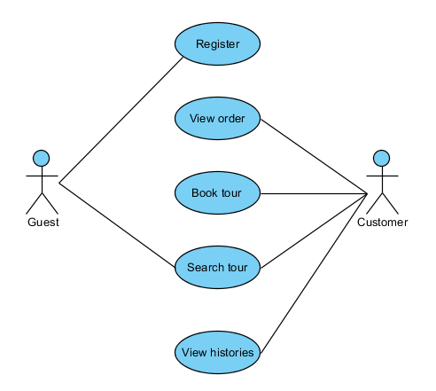

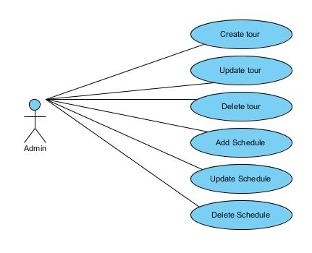

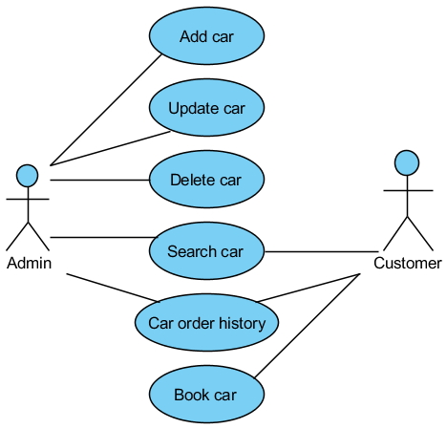

***1.Guest***

***a. Register to become a customer***

|  |  |  |
| --- | --- | --- |
| Author | Bui Ngoc Quang Anh | |
| Use Case Name | Register as Customer | |
| Actors | Guest | |
| Description | Guest wants to register with the website to become a customer | |
| Requirements | Guest provides Guest’s information | |
| Pre-conditions |  | |
| Post-conditions | Success : Guest creates a Customer account in this web site  Fail : Refill information | |
| Basic flow | Actor action:  1.Actor clicks “Register” link in Home page  3.Actor clicks “Agree” button  5.Actor input register’s information, select ‘Gender’ and click ‘Register’ button[Alternative 1] | System responses:  2.System redirects to Registration Policy page  4.System redirects to Register page and displays Registration form with the following control:  - ‘Username’ text field  - ‘Password’ text field  -‘Confirm Password’ text field  -‘Full Name’ text field  -‘Gender’ combo box  -‘Email’ text field  -‘Confirm Email’ text field  - ‘Nationality’ combo box  - ‘Address’ text field  - ‘Phone’ text field  - ‘Register’ button  6.System checks the information [Exception 1]  7.System inserts the account into database ,show message ,”Your account has been created!” and then redirects to Login page |
| Alternative flow | Actor Actions:  [Alternative 1]  1.Actor click ‘Back to Home’ button | System responses:  2.System returns to Home page |
| Exception | Actor Actions:  [Exception 1]  1.Actor lefts ‘Username’ text field blank  2.Username has already exists  3.Actor lefts ‘Password’ text field blank  4.Actor lefts ’Confirm Password’ text field blank  5.Password and confirm password don’t match  6.Actor lefts ‘Full Name’ text field blank  7.Actor lefts ‘Gender’ combo box blank  8.Actor lefts ‘Email’ text field blank  9.Actor lefts ‘Confirm Email’ text field blank  11.Email and Confirm Email don’t match  12.Actor lefts ‘Phone’ text field  13.Input phone not in numeric or phone length not in range 8-14 character | System responses:  System display message to Actor:  - ‘Username cannot be blank’  - ‘This Username has already exist’  - ‘Password cannot be blank’  - ‘Confirm Password cannot be blank’  - ‘Confirm Password not match password’  - ‘Full Name cannot be blank’  -‘Have to choose the gender’  -‘Email cannot be blank’  -‘Confirm Email cannot be blank’  -‘Confirm Email is not match password’  -‘Phone cannot be blank’  -‘The phone number should be numeric only and must be between 8 and 14 digits’ |

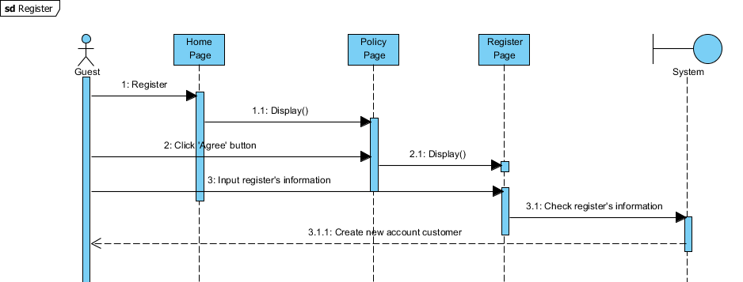

***b. Search tour***

|  |  |  |
| --- | --- | --- |
| Author | Bui Ngoc Quang Anh | |
| Use Case Name | Search tour | |
| Actors | Guest, Customer | |
| Description | Guest wants to search the tour information | |
| Requirements | Guest provides tour information for searching | |
| Pre-conditions |  | |
| Post-conditions | Success : Website will show the tour information which guest is looking for  Fail : Notify there are no result | |
| Basic flow | Actor action :  1.Actor provides information for search  3.Actor input search’s information, click ‘Search’ button | System responses :  2.System provides information for searching :  -‘Start Location’ combo box  -‘End Location’ combo box  Or  -‘From Date’ date picker  -‘To Date’ date picker  4.System checks the information and searches  5.System views the tour that match the search’s information provided by the Actor |
| Alternative flow | Actor action : | System responses : |
| Exception | Actor action : | System responses : |

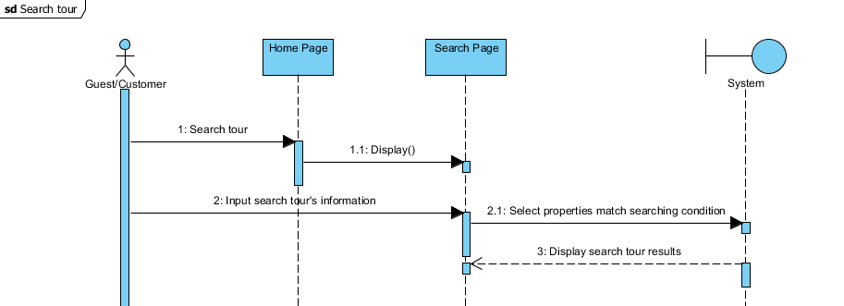

***2.Customer***

***a. Tour Detail***

|  |  |  |
| --- | --- | --- |
| Author | Bui Ngoc Quang Anh | |
| Use Case Name | Tour Details – Tours Cart | |
| Actors | Customer | |
| Description | Customer wants to book a tour | |
| Requirements | Customer click to the Tour details | |
| Pre-conditions |  | |
| Post-conditions | Success : Website will add the tour to Tours Cart and redirect automatically to Tours Cart  Fail : Notify an error | |
| Basic flow | Actor action :  1.Actor see the Tour Details  3.Actor click ‘Book’ button  5.Actor click ‘Confirm’ button  [Alternative 1], [ Alternative 2], [Alternative 3] | System responses :  2.Website shows the tour details in table :  -‘Tour Image’  -‘Tour Name’  -‘Start location’  -‘End location’  -‘Start date’  -‘End date’  -‘Min Participants’  -‘Max Participants’  -‘Current Quantity’  -‘Price’  -‘Tour status’  -‘Book’ submit button  -‘View Schedule’  4.Website will redirect automatically to Tours Cart with the tour details in table :  -‘Tour ID’  -‘Tour Name’  -‘Start date’  -‘End date’  -‘Price’  -‘Number of participants’ text box  -‘To Cash’  - ‘Select’ check box  -‘Total’  -‘Remove’ submit button  -‘Book More’ submit button  -‘Check Out’ submit button  -‘Update’ submit button  6.System will put the tour information into database Order |
| Alternative flow | Actor action :  [Alternative 1]  1.Actor click ‘Remove’ button  [Alternative 2]  1.Actor click ‘Book More’ button  [Alternative 3]  1Actor click ‘Update’ | System responses :  [Alternative 1]  2.Website will remove tour information in Cart  [Alternative 2]  2.Website will redirect automatically to Tour page for booking new tour  2.Website will update the cart with new quantity and cash |
| Exception | Actor action : | System responses : |

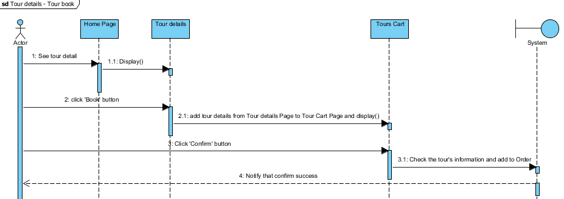

***b. View orders***

|  |  |  |
| --- | --- | --- |
| Author | Bui Ngoc Quang Anh | |
| Use Case Name | View Orders | |
| Actors | Customer | |
| Description | Customer see all of orders | |
| Requirements | Customer click View Orders | |
| Pre-conditions |  | |
| Post-conditions | Success : Website will show all of orders of customer  Fail : Notify an error | |
| Basic flow | Actor action :  1.Actor see the Tour Details  [Alternative 1], [Alternative 2] | System responses :  2.Website shows the order details in table :  -‘Order ID’  -‘Order date’  -‘Total’  -‘Status’  -‘Detail Order’ submit button  -‘Cancel Order’ submit button |
| Alternative flow | [Alternative 1]  1.Actor click ‘Detail Order’ button  [Alternative 2]  1.Actor click ‘Cancel Order’ button | 2.Website will redirect automatically to Order Detail page  2.System will cancel the order in database |
| Exception | Actor action : | System responses : |

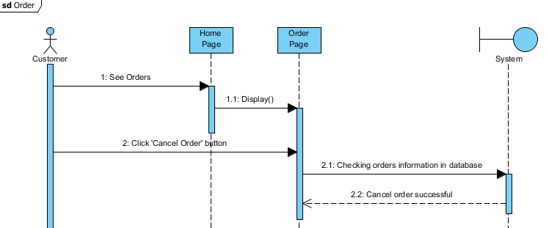

***c.View Schedule***

|  |  |  |
| --- | --- | --- |
| Author | Bui Ngoc Quang Anh | |
| Use Case Name | View schedule | |
| Actors | Customer | |
| Description | Customer see all of orders | |
| Requirements | Customer click View Orders | |
| Pre-conditions |  | |
| Post-conditions | Success : Website will show all of orders of customer  Fail : Notify an error | |
| Basic flow | Actor action :  1.Actor see the Tour schedules  [Alternative 1], [Alternative 2] | System responses :  2.Website shows the schedules details in table :  -‘Schedule Image’  -‘ Schedule Description’  -‘Back’ submit button |
| Alternative flow | [Alternative 1]  1.Actor click ‘Back’  button | 2.Website will redirect automatically to Tour Detail page |
| Exception | Actor action : | System responses : |

***d. View Order history***

|  |  |  |
| --- | --- | --- |
| Author | Bui Ngoc Quang Anh | |
| Use Case Name | View Order histoty | |
| Actors | Customer | |
| Description | Customer wants to see the history | |
| Requirements | Customer click View History | |
| Pre-conditions |  | |
| Post-conditions | Success : Website will show all of Histories of customer  Fail : Notify an error | |
| Basic flow | Actor action :  1.Actor see the Tour Details  [Alternative 1], [Alternative 2] | System responses :  2.Website shows the History details in table :  -‘Order ID’  -‘Order date’  -‘Order cancel date’  -‘Description’  -‘Total price’  -‘Status’  -‘View History’ submit button  -‘Cancel Order’ submit button |
| Alternative flow | [Alternative 1]  1.Actor click ‘View History’ button  [Alternative 2]  1.Actor click ‘Cancel Order’ button | 2.Website will redirect automatically to History page  2.System will cancel the order in database |
| Exception | Actor action : | System responses : |

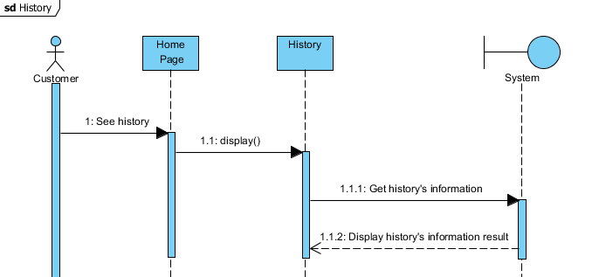

***e.View Flight information***

|  |  |  |
| --- | --- | --- |
| Author | Bui Ngoc Quang Anh | |
| Use Case Name | View flight information | |
| Actors | Guest, Customer | |
| Description | Guest/Customer want to see the flight information | |
| Requirements |  | |
| Pre-conditions |  | |
| Post-conditions | Success : Website will show the flight information which guest is looking for  Fail : Notify there are no result | |
| Basic flow | Actor action :  1.Actor click on flight information image  3.Actor clicks ‘View Detail’ button | System responses :  2.System redirect into Flight Information page with the Flight’s information in the table :  - ‘Flight Name’  - ‘Price’  - ‘View Detail’ submit button  4.System redirect into Flight Detail page |
| Alternative flow | Actor action : | System responses : |
| Exception | Actor action : | System responses : |

***d. View Flight Detail***

|  |  |  |
| --- | --- | --- |
| Author | Bui Ngoc Quang Anh | |
| Use Case Name | View flight detail | |
| Actors | Guest, Customer | |
| Description | Guest/Customer want to see the flight detail | |
| Requirements |  | |
| Pre-conditions |  | |
| Post-conditions | Success : Website will show the flight detail which guest is looking for  Fail : Notify there are no result | |
| Basic flow | Actor action :  1.Actor click on ‘Back to Flight’ Button | System responses :  2.System redirect into Flight Information page with the Flight’s information in the table :  - ‘Flight Name’  - ‘Price’  - ‘View Detail’ submit button |
| Alternative flow | Actor action : | System responses : |
| Exception | Actor action : | System responses : |

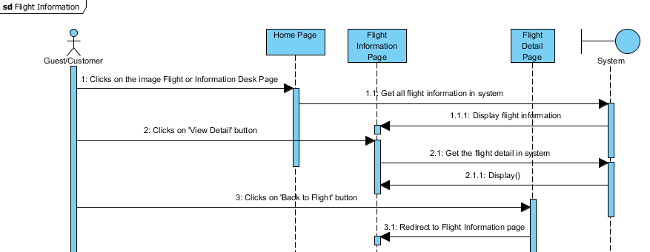

***3.Admin***

***a. Create Tour***

|  |  |  |
| --- | --- | --- |
| Author | Hoang Dinh Manh | |
| Use Case Name | Create Tour | |
| Actors | Admin | |
| Description | Admin wants to create new tour | |
| Requirements | Admin provides tour information | |
| Pre-conditions |  | |
| Post-conditions |  | |
| Basic flow | Action:  1. Admin click “Create Tour” in Management page | System responses:  2. System redirects to Create tour page and displays Create tour form with the following control:  - ‘Tour Name’ text field  - ‘Start Date’ date box  -‘End Date’ date box  -‘Start at’ text field  -‘End at’ text field  -‘Quantity min’ text field  -‘Quantity max’ text field  - ‘Quantity require’ text field  - ‘Price’ text field  - ‘Description text field  - ‘Image’ browse file  - ‘Create Tour’ button  - ‘Reset’ button  - ‘Back’ button  3. System checks the information [Exception 1]  4. System inserts new tour into database ,show message ,”Your Tour has been created!” and then redirects to Management Page |
| Alternative flow | Admin Actions:  [Alternative 1]  1.Actor click ‘Back’ to Management page’ | System responses:  2.System returns to Management page |
| Exception | Admin Actions:  [Exception 1]  1.Actor lefts ‘Tour Name’ text field blank  2. Tour Name has already exists  3.Actor lefts ‘Start Date’ text field blank  4.Actor lefts ‘End date’ text field blank  5.Actor lefts ‘Start date’ text field blank  6.Actor lefts ‘Start at’ text field blank  7.Actor lefts ‘End at’ text field blank  8.Actor lefts ‘Quantity min’ text field blank  9.Actor lefts ‘Quantity max’ text field blank  10.Actor lefts ‘Price’ text field blank  11. Actor left ‘Description’ text area  12. Actor forget to select image of tour  13.Input price not in numeric | System responses:  System display message to Admin:  - ‘Tour Name cannot be blank’  - ‘This Tour Name has already exist’  - ‘End date cannot be blank’  - ‘Start date cannot be blank’  - ‘Start at cannot be blank’  - ‘End at cannot be blank’  - ‘Quantity min cannot be blank’  - ‘Quantity max cannot be blank’  - ‘Price cannot be blank’  - ‘Description cannot be blank’  - ‘Please insert Image’  - ‘Price invalid’ |

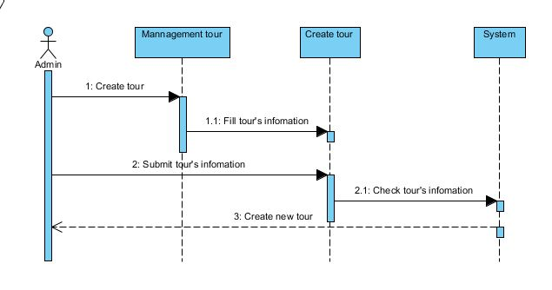

***b. Update tour***

|  |  |  |
| --- | --- | --- |
| Author | Hoang Dinh Manh | |
| Use Case Name | Update tour | |
| Actors | Admin | |
| Description | Admin wants to update the tour information | |
| Requirements | Admin provides tour information for update | |
| Pre-conditions |  | |
| Post-conditions | Success : Update information of the tour  Fail : Notify update fail and back to Management page | |
| Basic flow | Actor action :  1.Actor clicks “Update” link in Management Page  3.Actor input Update’s information, click ‘Update’ | System responses :  2.System redirects to Update tour page and displays Update tour form with the following control:  - ‘Tour Name’ text field  - ‘Start Date’ date box  -‘End Date’ date box  -‘Start at’ text field  -‘End at’ text field  -‘Quantity min’ text field  -‘Quantity max’ text field  - ‘Price’ text field  - ‘Description text field  - ‘Image’ browse file  - ‘Update Tour’ button  - ‘Reset’ button  - ‘Back’ button    4. System checks the information [Exception 1]  5. System Update this tour into database ,show message ,”Your Tour has been Update!” and then redirects to Management Page |
| Alternative flow | Actor action :  [Alternative 1]  1.Actor click ‘Back’ to Management page’ | System responses :  2.System returns to Management page |
| Exception | Admin Actions:  [Exception 1]  1.Actor lefts ‘Tour Name’ text field blank  2. Tour Name has already exists  3.Actor lefts ‘Start Date’ text field blank  4.Actor lefts ‘End date’ text field blank  5.Actor lefts ‘Start date’ text field blank  6.Actor lefts ‘Start at’ text field blank  7.Actor lefts ‘End at’ text field blank  8.Actor lefts ‘Quantity min’ text field blank  9.Actor lefts ‘Quantity max’ text field blank  10.Actor lefts ‘Price’ text field blank  11. Actor left ‘Description’ text area  12. Actor forget to select image of tour  13.Input price not in numeric | System responses :  System display message to Admin:  - ‘Tour Name cannot be blank’  - ‘This Tour Name has already exist’  - ‘End date cannot be blank’  - ‘Start date cannot be blank’  - ‘Start at cannot be blank’  - ‘End at cannot be blank’  - ‘Quantity min cannot be blank’  - ‘Quantity max cannot be blank’  - ‘Price cannot be blank’  - ‘Description cannot be blank’  - ‘Please insert Image’  - ‘Price invalid’ |

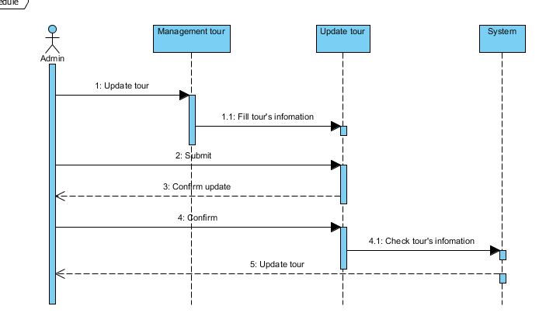

***c. Delete tour***

|  |  |  |
| --- | --- | --- |
| Author | Hoang Dinh Manh | |
| Use Case Name | Delete tour | |
| Actors | Admin | |
| Description | Admin wants to delete the tour information | |
| Requirements | Admin provides tour for delete | |
| Pre-conditions |  | |
| Post-conditions | Success : Delete information of the tour  Fail : Notify Delete fail and back to Management page | |
| Basic flow | Actor action :  1. Admin click “Delete Tour” in Management page  3.Actor click ‘OK’ in message | System responses :  2.System checks the information  4.System Delete tour and show message ,”Your tour has been delete!” and then redirects to Management page |
| Alternative flow | Actor action : | System responses : |
| Exception | Actor action : | System responses : |

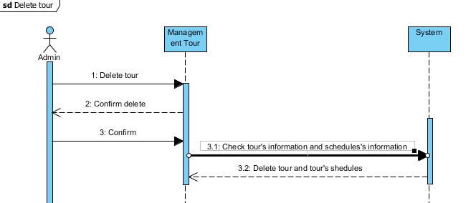

***d. Add Schedule***

|  |  |  |
| --- | --- | --- |
| Author | Hoang Dinh Manh | |
| Use Case Name | Add Schedule | |
| Actors | Admin | |
| Description | Admin wants to Add Schedule | |
| Requirements | Admin provides for add new Schedule | |
| Pre-conditions |  | |
| Post-conditions | Add new schedule of the tour | |
| Basic flow | Actor action :  1. Actor click ‘Schedule’ in Management page  3. Actor click ‘Create Schedule’ in Manage Schedule page | System responses :  2. System redirects to Manage Schedule page and displays Manage Schedule form with the following control and Schedules’s information in table:  -‘Day’  -‘Description’  -‘Image’  -‘Action’ include these button:  + ‘Update’ button  + ‘Delete’ button  - ‘Done’ button  - ‘Reset’ button  - ‘Back’ button  - ‘Create Schedule’ button  4. System redirects to Add Schedule page and displays Add Schedule form with the following control:  - ‘Day’ text field  - ‘Description’ text area  - ‘Image’ file browse  - ‘Done’ button  - ‘Reset’ button  - ‘Back’ button  4. System checks the information [Exception 1]  5. System Insert Schedule into database ,show message ,”Your Schedule has been Insert!” and then redirects to Management Page |
| Alternative flow | Actor action :  Admin Actions:  [Alternative 1]  1.Actor click ‘Back’ to Management page’ | System responses :  2.System returns to Management page |
| Exception | Actor action :  [Exception 1]  1.Actor lefts ‘Day’ text field blank  3.Actor lefts ‘Description’ text area blank  4. Actor forget to select image of tour | System responses :  System display message to Admin:  - ‘Day cannot be blank’  - ‘Description has already exist’  - ‘Please insert Image’ |

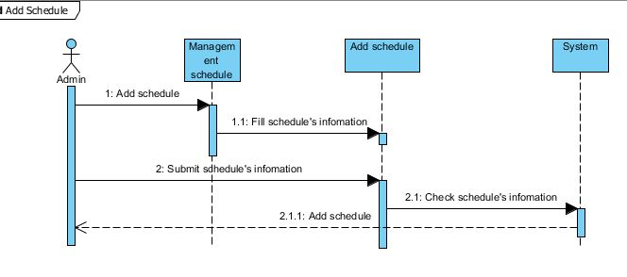

***e. Delete Schedule***

|  |  |  |
| --- | --- | --- |
| Author | Hoang Dinh Manh | |
| Use Case Name | Delete Schedule | |
| Actors | Admin | |
| Description | Admin wants to Delete Schedule | |
| Requirements | Admin provides for Delete Schedule | |
| Pre-conditions |  | |
| Post-conditions | Delete schedule of the tour | |
| Basic flow | Actor action :  1. Actor click ‘Schedule’ in Management page  3. Actor click ‘Delete’ in Manage Schedule page | System responses :  2. System redirects to Manage Schedule page and displays Manage Schedule form with the following control and Schedules’s information in table:  -‘Day’  -‘Description’  -‘Image’  -‘Action’ include these button:  + ‘Update’ button  + ‘Delete’ button  - ‘Done’ button  - ‘Reset’ button  - ‘Back’ button  - ‘Create Schedule’ button  4. System checks the information [Exception 1]  5. System delete this schedule in database ,show message ,”Your Schedule has been Delete!” and then redirects to Management Page |
| Alternative flow | Actor action : | System responses : |
| Exception | Actor action : | System responses : |

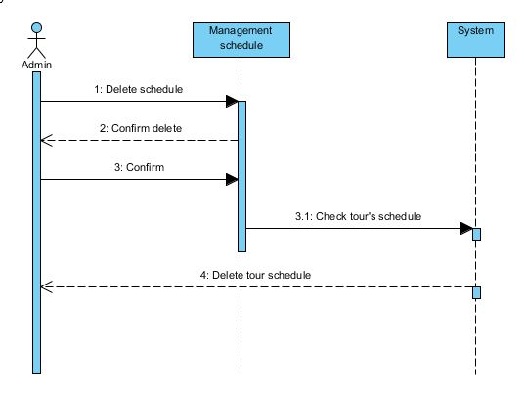

***g. Update Schedule***

|  |  |  |
| --- | --- | --- |
| Author | Hoang Dinh Manh | |
| Use Case Name | Update Schedule | |
| Actors | Admin | |
| Description | Admin wants to Update Schedule | |
| Requirements | Admin provides for Update Schedule | |
| Pre-conditions |  | |
| Post-conditions | Update schedule of the tour | |
| Basic flow | Actor action :  1. Actor click ‘Schedule’ in Management page  3. Actor click ‘Update’ in Manage Schedule page | System responses :  2. System redirects to Manage Schedule page and displays Manage Schedule form with the following control and Schedules’s information in table:  -‘Day’  -‘Description’  -‘Image’  -‘Action’ include these button:  + ‘Update’ button  + ‘Delete’ button  - ‘Done’ button  - ‘Reset’ button  - ‘Back’ button  - ‘Create Schedule’ button  4. System redirects to Update Schedule page and displays Update Schedule form with the following control:  - ‘Day’ text field  - ‘Description’ text area  - ‘Image’ file browse  - ‘Done’ button  - ‘Reset’ button  - ‘Back’ button  4. System checks the information [Exception 1]  5. System Insert Schedule into database ,show message ,”Your Schedule has been Update!” and then redirects to Management Page |
| Alternative flow | Actor action :  Admin Actions:  [Alternative 1]  1.Actor click ‘Back’ to Management page’ | System responses :  2.System returns to Management page |
| Exception | Actor action :  [Exception 1]  1.Actor lefts ‘Day’ text field blank  3.Actor lefts ‘Description’ text area blank  4. Actor forget to select image of tour | System responses :  System display message to Admin:  - ‘Day cannot be blank’  - ‘Description has already exist’  - ‘Please insert Image’ |

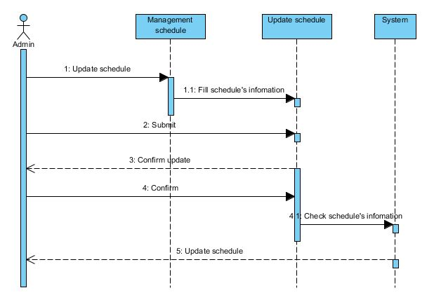

***h. Add car to database***

|  |  |  |
| --- | --- | --- |
| Author | Nguyen Anh Tuan | |
| Use Case Name | Add car to database | |
| Actors | Admin | |
| Description | Admin add car to database for user to book | |
| Requirements | Admin provide car's information | |
| Pre-conditions |  | |
| Post-conditions | Success: a car is added to database  Fail: check input or server is down | |
| Basic flow | Actor action:  1.Actor clicks “Add car” link in admin page  5.Actor input car's information and click add button[Alternative 1] | System responses:  2.System redirects to car adding page and displays form with the following control:  -Model textbox  -Type textbox  -Seating Capacity textbox  -Have/not have Air-conditioner checkbox  -Description  -Image  -Add button  -Reset button  6.System checks the information [Exception 1]  7.System inserts the car into database ,show message ,”Car added successfully!” and then redirects to Admin page |
| Alternative flow | Actor Actions:  [Alternative 1]  1.Actor click reset button | System responses:  2.Form will be clear |
| Exception | Actor Actions:  [Exception 1]  1.Actor lefts model text field blank  2.Model has already exists  3.Actor lefts Type text field blank  4.Actor lefts Seating capacity text field blank  5.Actor insert non-number into seating capacity textfield  6.Actor left Description textfield blank  7.Actor left Image textfield blank | System responses:  System display message to Actor:  -Model cannot be blank  -This Model has already exist  -Type cannot be blank  -Seating capacity cannot be blank  -Only number allow in seating capacity  -Description cannot be blank  -Image cannot be blank |

1. ***Add car to database***

|  |  |  |
| --- | --- | --- |
| Author | Nguyễn Anh Tuấn | |
| Use Case Name | Add car to database | |
| Actors | Admin | |
| Description | Admin add car to database for user to book | |
| Requirements | Admin provide car's information | |
| Pre-conditions |  | |
| Post-conditions | Success: a car is added to database  Fail: check input or server is down | |
| Basic flow | Actor action:  1.Actor clicks “Add car” link in admin page  5.Actor input car's information and click add button[Alternative 1] | System responses:  2.System redirects to car adding page and displays form with the following control:  -Model textbox  -Type textbox  -Seating Capacity textbox  -Have/not have Air-conditioner checkbox  -Description textarea  -Image upload control  -Stock quantity textbox  -Price textbox  -Add button  -Reset button  6.System checks the information [Exception 1]  7.System inserts the car into database ,show message ,”Insert successfully!” |
| Alternative flow | Actor Actions:  [Alternative 1]  1.Actor click reset button | System responses:  2.Form will be clear |
| Exception | Actor Actions:  [Exception 1]  1.Actor lefts model text field blank  2.Model has already exists  3.Actor lefts Type text field blank  4.Actor lefts Seating capacity text field blank  5.Actor insert non-number into seating capacity textfield  6.Actor left Description textfield blank  7.Actor left Image textfield blank  8.Actor insert non-number into stock quantity textfield  9.Actor left stock quantity textfield blank  10.Actor left price textfield blank  11.Actor insert non-number into price textfield | System responses:  System display message to Actor:  -please fill in every field  -please don't input character into number only textfield |

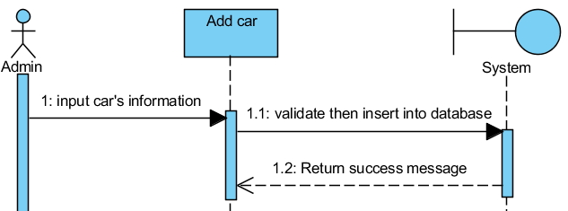

***j. Search for car***

|  |  |  |
| --- | --- | --- |
| Author | Nguyễn Anh Tuấn | |
| Use Case Name | Search for car | |
| Actors | User | |
| Description | User search for car to book | |
| Requirements | User provide search criteria | |
| Pre-conditions |  | |
| Post-conditions | Success: cars that match are displayed, if not none is displayed  Fail: server is down | |
| Basic flow | Actor action:  1.Actor clicks “Search for car” link in homepage  3.Actor input search criteria and click search button[Alternative 1] | System responses:  2.System redirects to search page and displays form with the following control:  -Model textbox  -Type textbox  -Seating Capacity textbox  -Have/not have Air-conditioner radio button  -Stock quantity more than textbox  -Price from textbox  -Price to textbox  -search button  4.System checks the information [Exception 1]  5.System return search result |
| Alternative flow | Actor Actions:  [Alternative 1]  1.There already 5 most popular car to choose from | System responses: |
| Exception | Actor Actions:  [Exception 1]  1.Actor insert non-number into number only textfield | System responses:  System display message to Actor:  -please don't input character into number only textfield |

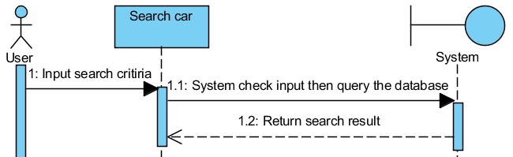

***k. Book car***

|  |  |  |
| --- | --- | --- |
| Author | Nguyễn Anh Tuấn | |
| Use Case Name | Book car | |
| Actors | User | |
| Description | User book car | |
| Requirements | User provide booking information | |
| Pre-conditions |  | |
| Post-conditions | Success: car booked success  Fail: check input or server is down | |
| Basic flow | Actor action:  1.Actor clicks “Search for car” link in homepage  3.Actor input search criteria and click search button[Alternative 1]  6.Actor clicks description button in search page  8.Actor click book button is description page  10.Actor input booking details and click add to cart button[Alternative 1] | System responses:  2.System redirects to search page and displays form with the following control:  -Model textbox  -Type textbox  -Seating Capacity textbox  -Have/not have Air-conditioner radio button  -Stock quantity more than textbox  -Price from textbox  -Price to textbox  -search button  4.System checks the information [Exception 1]  5.System return search result  7.System redirects to description page and displays car's details:  -Model -image -Type -Airconditioner -quantity left -Price  9.System redirects to booking page and displays form with the following control:  -Quantity textbox  -Driver required checkbox  -Pickup date textbox  -Dropoff date textbox  -add to cart button  -reset button  9.System checks the information [Exception 2]  10.System inserts booking details into session and then redirects to shopping cart page |
| Alternative flow | Actor Actions:  [Alternative 1]  1.Actor click reset button | System responses:  2.Form will be clear |
| Exception | Actor Actions:  [Exception 1]  1.Actor insert non-number into number only textfield  [Exception 2]  1.Actor lefts quantity text field blank  2.Actor insert non-number into quantity textfield  3.Actor insert 0 into quantity textfield  4.Actor lefts pickup/dropoff date textfield blank  5.Actor insert non-date into pickup/dropoff date textfield  6.Actor insert pickup date before today  7.Actor insert dropoff date before pickup date | System responses:  System display message to Actor:  -please don't input character into number only textfield  -please fill in every field  -please input valid date into date only textfield  -your quantity cannot be zero  -pickup date cannot be before today  -dropoff date cannot be before pickupdate |

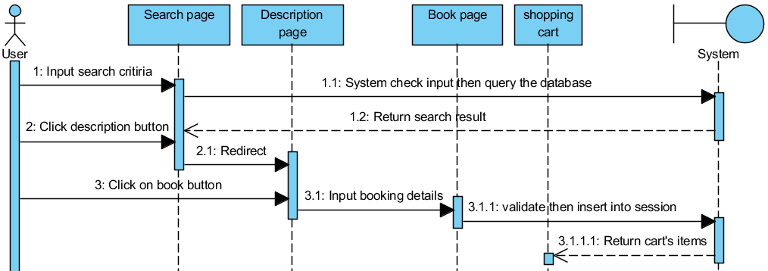

***l. Update car***

|  |  |  |
| --- | --- | --- |
| Author | Nguyễn Anh Tuấn | |
| Use Case Name | Update car details | |
| Actors | Admin | |
| Description | Admin update car's details | |
| Requirements | Admin provide new car's details | |
| Pre-conditions |  | |
| Post-conditions | Success: new details is updated in the database  Fail: check input or server is down | |
| Basic flow | Actor action:  1.Actor clicks “Search for car” link in homepage  3.Actor input search criteria and click search button[Alternative 1]  6.Actor clicks update button in search page  8.Actor click update button | System responses:  2.System redirects to search page and displays form with the following control:  -Model textbox  -Type textbox  -Seating Capacity textbox  -Have/not have Air-conditioner radio button  -Stock quantity more than textbox  -Price from textbox  -Price to textbox  -search button  4.System checks the information [Exception 1]  5.System return search result  7.System redirects to update page and displays form with the following control:  -Model textbox  -Type textbox  -Seating Capacity textbox  -Have/not have Air-conditioner checkbox  -Description textarea  -Image upload control  -Stock quantity textbox  -Price textbox  -update button  9.System checks the information [Exception 2]  10.System update car's details into database then show “update successfully” |
| Alternative flow | Actor Actions:  [Alternative 1]  1.There already top 5 car display | System responses: |
| Exception | Actor Actions:  [Exception 1]  1.Actor insert non-number into number only textfield  [Exception 2]  1.Actor lefts model text field blank  2.Model has already exists  3.Actor lefts Type text field blank  4.Actor lefts Seating capacity text field blank  5.Actor insert non-number into seating capacity textfield  6.Actor left Description textfield blank  7.Actor left Image textfield blank  8.Actor insert non-number into stock quantity textfield  9.Actor left stock quantity textfield blank  10.Actor left price textfield blank  11.Actor insert non-number into price textfield | System responses:  System display message to Actor:  -please don't input character into number only textfield  -please fill in every field |

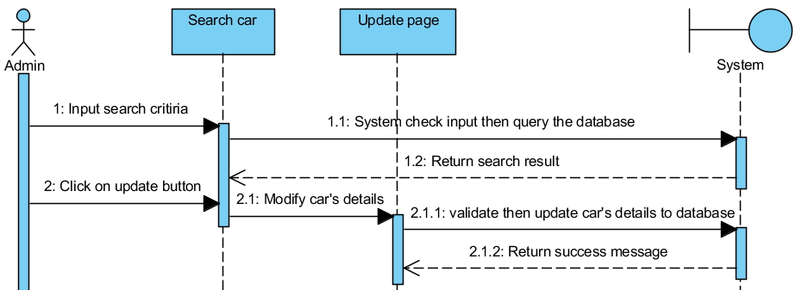

***m. Delete car***

|  |  |  |
| --- | --- | --- |
| Author | Nguyễn Anh Tuấn | |
| Use Case Name | Delete car | |
| Actors | Admin | |
| Description | Admin delete car | |
| Requirements |  | |
| Pre-conditions |  | |
| Post-conditions | Success: car is set to disable in database  Fail: server is down | |
| Basic flow | Actor action:  1.Actor clicks “Search for car” link in homepage  3.Actor input search criteria and click search button[Alternative 1]  6.Actor clicks delete button in search page  8.Actor click yes | System responses:  2.System redirects to search page and displays form with the following control:  -Model textbox  -Type textbox  -Seating Capacity textbox  -Have/not have Air-conditioner radio button  -Stock quantity more than textbox  -Price from textbox  -Price to textbox  -search button  4.System checks the information [Exception 1]  5.System return search result  7.Prompt for comfirmation, display “Do you really want to delete this car? This action cannot be undone!”  9.Car's status is set to deleted then show “delete successfully” |
| Alternative flow | Actor Actions:  [Alternative 1]  1.There already top 5 car display | System responses: |
| Exception | Actor Actions:  [Exception 1]  1.Actor insert non-number into number only textfield | System responses:  System display message to Actor:  -please don't input character into number only textfield |

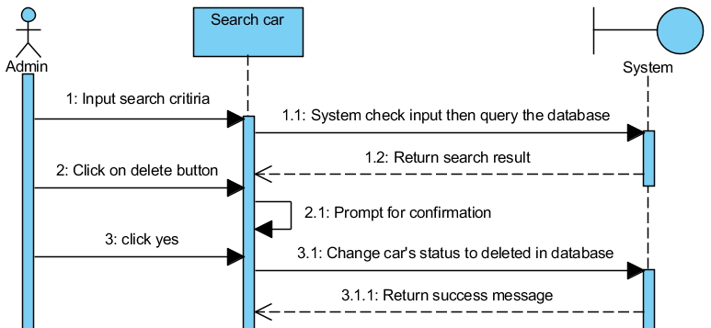

***n. View car order***

|  |  |  |
| --- | --- | --- |
| Author | Nguyễn Anh Tuấn | |
| Use Case Name | view car order | |
| Actors | user | |
| Description | user view all their car orders | |
| Requirements | User provide date range | |
| Pre-conditions |  | |
| Post-conditions | Success: return all car orders  Fail: check input or server is down | |
| Basic flow | Actor action:  1.Actor clicks “view car orders” link in homepage  3.Actor input search criteria and click search button[Alternative 1] | System responses:  2.System redirects to view car order page and displays form with the following control:  -From textbox  -To textbox  -search button  4.System checks the information [Exception 1]  5.System return search result which have these columns  -order number  -order date  -status |
| Alternative flow | Actor Actions:  [Alternative 1]  1.There already 5 most recent order display |  |
| Exception | Actor Actions:  [Exception 1]  1.Actor insert non-date into From/To textfield | System responses:  System display message to Actor:  -please input valid date into date only textfield |

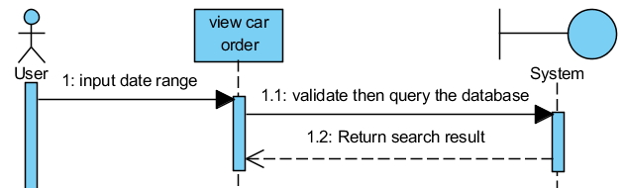

***o. Cancel car order***

|  |  |  |
| --- | --- | --- |
| Author | Nguyễn Anh Tuấn | |
| Use Case Name | cancel car order | |
| Actors | user | |
| Description | user cancel their car order | |
| Requirements | User provide date range | |
| Pre-conditions |  | |
| Post-conditions | Success: cancel car order  Fail: server is down | |
| Basic flow | Actor action:  1.Actor clicks “view car orders” link in homepage  3.Actor input search criteria and click search button[Alternative 1]  6.Actor click cancel  8.Actor click yes | System responses:  2.System redirects to view car order page and displays form with the following control:  -From textbox  -To textbox  -search button  4.System checks the information [Exception 1]  5.System return search result which have these columns  -order number  -order date  -status  7.System prompt for confirmation  9.Order status changed to canceled, then show all orders |
| Alternative flow | Actor Actions:  [Alternative 1]  1.There already top 5 order display | System responses: |
| Exception | Actor Actions:  [Exception 1]  1.Actor insert non-date into From/To textfield | System responses:  System display message to Actor:  -please input valid date into date only textfield |

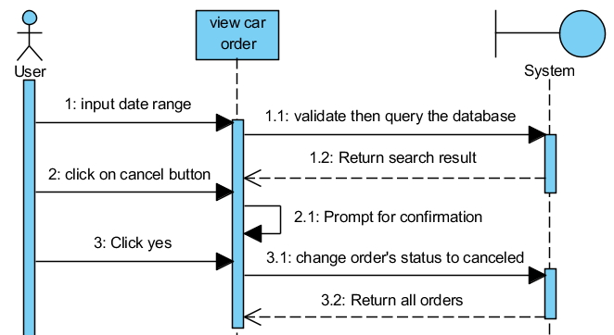

p. Car checkout

|  |  |  |
| --- | --- | --- |
| Author | Nguyễn Anh Tuấn | |
| Use Case Name | Car place order | |
| Actors | user | |
| Description | user place order | |
| Requirements |  | |
| Pre-conditions |  | |
| Post-conditions | Success: place order  Fail: server is down | |
| Basic flow | Actor action:  1.Actor clicks checkout in shopping cart page  3.Actor click place order | System responses:  2.System redirects to view car order page and displays form with the following control:  -User's billing address  -order number  -order date  -status  -Quantity  -Model  -Do you want a driver?  -Pickup date  -Dropoff date  -Total cost  -Order cost  -place order button  4.Order inserted into database then show “order place successfully” |
| Alternative flow |  |  |
| Exception |  |  |

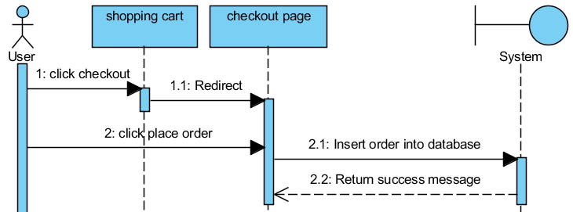

q. Car report

|  |  |  |
| --- | --- | --- |
| Author | Nguyễn Anh Tuấn | |
| Use Case Name | Car report | |
| Actors | User | |
| Description | User search for top 10 car in a date range | |
| Requirements | User provide date range | |
| Pre-conditions |  | |
| Post-conditions | Success: cars that match are displayed, if not none is displayed  Fail: server is down | |
| Basic flow | Actor action:  1.Actor clicks show report link in homepage  3.Actor input date range and click search report button | System responses:  2.System redirects to search page and displays form with the following control:  -From textbox  -To textbox  -search report button  4.System checks the information [Exception 1]  5.System return search result |
| Alternative flow |  |  |
| Exception | Actor Actions:  [Exception 1]  1.Actor insert non-date into date only textfield | System responses:  System display message to Actor:  -please input valid date into date only textfield |

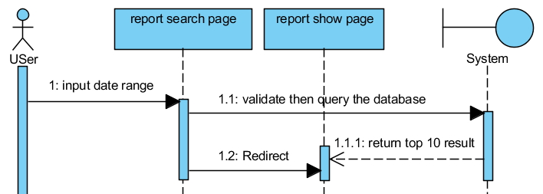***3.Entity Relationship Diagram (ERD)***

***a. Logical***

Customer

ScheduleTour

n

1

n

n

1

1

n

1

n

1

carOrder

Car

carQuantity

CancelOrderTour

OrderTour

Tour

OrderTourDetail

has

has

has

has

has

has

has

has

n

n

1

1

1

n

***b. Table***

***3.1.1 Customer***

Customer

***3.3.2 Order Tour***

OrderTour

***3.3.3 Order Tour Detail***

OrderTourDetail

***3.3.4 Cancel Order Tour***

CancelOrderTour

***3.3.5 Tour***

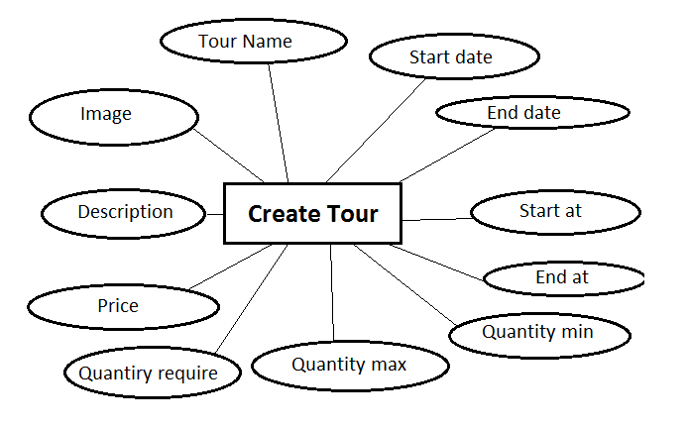

***3.3.6 Schedule***

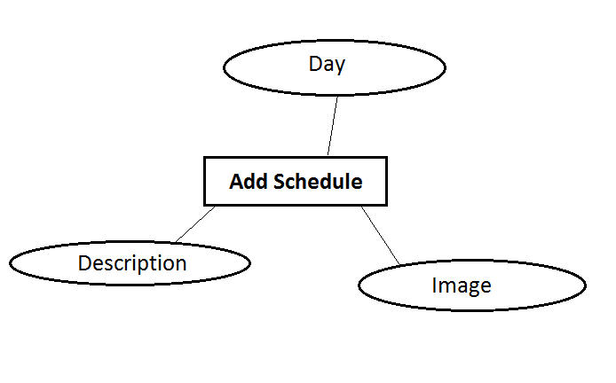

***3.3.7 Car***

Car

***3.3.8 carQuantity***

CarQuantity

***3.3.9 carOrder***

CarOrder

Task Sheet

***Task Sheet***

|  |  |  |  |  |  |  |  |  |  |
| --- | --- | --- | --- | --- | --- | --- | --- | --- | --- |
| **Project Ref. No 1** | | Project Title | **Activity Plan Prepared By** | **Date of Preparation of Activity Plan** | | | | | |
| Sr.No | Task | **Start Date** | **End Date** | **Actual Days** | **Member’s name** | | **Status** |
| **Review 1** | | | | | | | | | |
| 1 | Introduction | East2West | Bui Ngoc Quang Anh | 4/1/2013 | 4/4/2013 | 3 | Bui Ngoc Quang Anh | | Finish |
| 2 | Problem Definition | East2West | Bui Ngoc Quang Anh | 4/1/2013 | 4/4/2013 | 3 | Bui Ngoc Quang Anh | | Finish |
| 3 | Requirements and Business Flow | East2West | Bui Ngoc Quang Anh | 4/1/2013 | 4/4/2013 | 3 | Bui Ngoc Quang Anh | | Finish |
| 4 | Customer Requirement Specification | East2West | Bui Ngoc Quang Anh | 4/1/2013 | 4/4/2013 | 3 | Bui Ngoc Quang Anh | | Finish |
| **Review 2** | | | | | | | | | |
| Use Case and Sequence Diagram | | | | | | | | | |
| 1 | Use Case | East2West | Bui Ngoc Quang Anh | 4/5/2013 | 4/9/2013 | 4 | | Bui Ngoc Quang Anh | Finish |
| 2 | Sequence Diagram | East2West | Bui Ngoc Quang Anh | 4/5/2013 | 4/9/2013 | 4 | | Bui Ngoc Quang Anh | Finish |
| 3 | Register to become a customer | East2West | Bui Ngoc Quang Anh | 4/5/2013 | 4/9/2013 | 4 | | Bui Ngoc Quang Anh | Finish |
| 4 | Search tour | East2West | Bui Ngoc Quang Anh | 4/5/2013 | 4/9/2013 | 4 | | Bui Ngoc Quang Anh | Finish |
| 5 | Tour detail | East2West | Bui Ngoc Quang Anh | 4/5/2013 | 4/9/2013 | 4 | | Bui Ngoc Quang Anh | Finish |
| 6 | View orders | East2West | Bui Ngoc Quang Anh | 4/5/2013 | 4/9/2013 | 4 | | Bui Ngoc Quang Anh | Finish |
| 7 | View history | East2West | Bui Ngoc Quang Anh | 4/5/2013 | 4/9/2013 | 4 | | Bui Ngoc Quang Anh | Finish |
| 8 | View schedule | East2West | Bui Ngoc Quang Anh | 4/5/2013 | 4/9/2013 | 4 | | Bui Ngoc Quang Anh | Finish |
| 9 | Create Tour | East2West | Bui Ngoc Quang Anh | 4/5/2013 | 4/9/2013 | 4 | | Hoang Dinh Manh | Finish |
| 10 | Update tour | East2West | Bui Ngoc Quang Anh | 4/5/2013 | 4/9/2013 | 4 | | Hoang Dinh Manh | Finish |
| 11 | Delete tour | East2West | Bui Ngoc Quang Anh | 4/5/2013 | 4/9/2013 | 4 | | Hoang Dinh Manh | Finish |
| 12 | Add Schedule | East2West | Bui Ngoc Quang Anh | 4/5/2013 | 4/9/2013 | 4 | | Hoang Dinh Manh | Finish |
| 13 | Delete Schedule | East2West | Bui Ngoc Quang Anh | 4/5/2013 | 4/9/2013 | 4 | | Hoang Dinh Manh | Finish |
| 14 | Update Schedule | East2West | Bui Ngoc Quang Anh | 4/5/2013 | 4/9/2013 | 4 | | Hoang Dinh Manh | Finish |
| 15 | Add car | East2West | Bui Ngoc Quang Anh | 4/5/2013 | 4/9/2013 | 4 | | Nguyen Anh Tuan | Finish |
| 16 | Search car | East2West | Bui Ngoc Quang Anh | 4/5/2013 | 4/9/2013 | 4 | | Nguyen Anh Tuan | Finish |
| 17 | Book car | East2West | Bui Ngoc Quang Anh | 4/5/2013 | 4/9/2013 | 4 | | Nguyen Anh Tuan | Finish |
| 18 | Update car | East2West | Bui Ngoc Quang Anh | 4/5/2013 | 4/9/2013 | 4 | | Nguyen Anh Tuan | Finish |
| 19 | Delete car | East2West | Bui Ngoc Quang Anh | 4/5/2013 | 4/9/2013 | 4 | | Nguyen Anh Tuan | Finish |
| 20 | View car order | East2West | Bui Ngoc Quang Anh | 4/5/2013 | 4/9/2013 | 4 | | Nguyen Anh Tuan | Finish |
| 21 | Cancel car order | East2West | Bui Ngoc Quang Anh | 4/5/2013 | 4/9/2013 | 4 | | Nguyen Anh Tuan | Finish |
| *Entity Relationship Diagram (ERD)* | | | | | | | | | |
| 1 | Logical | East2West | Bui Ngoc Quang Anh | 4/5/2013 | 4/9/2013 | 4 | | Bui Ngoc Quang Anh | Finish |
| *Table* | | | | | | | | | |
| 1 | Customer | East2West | Bui Ngoc Quang Anh | 4/5/2013 | 4/9/2013 | 4 | | Bui Ngoc Quang Anh | Finish |
| 2 | OrderTour | East2West | Bui Ngoc Quang Anh | 4/5/2013 | 4/9/2013 | 4 | | Bui Ngoc Quang Anh | Finish |
| 3 | OrderTourDetail | East2West | Bui Ngoc Quang Anh | 4/5/2013 | 4/9/2013 | 4 | | Bui Ngoc Quang Anh | Finish |
| 4 | CancelOrderTour | East2West | Bui Ngoc Quang Anh | 4/5/2013 | 4/9/2013 | 4 | | Bui Ngoc Quang Anh | Finish |
| 5 | Tour | East2West | Bui Ngoc Quang Anh | 4/5/2013 | 4/9/2013 | 4 | | Hoang Dinh Manh | Finish |
| 6 | Schedule | East2West | Bui Ngoc Quang Anh | 4/5/2013 | 4/9/2013 | 4 | | Hoang Dinh Manh | Finish |
| 7 | Car | East2West | Bui Ngoc Quang Anh | 4/5/2013 | 4/9/2013 | 4 | | Nguyen Anh Tuan | Finish |
| 8 | CarOrder | East2West | Bui Ngoc Quang Anh | 4/5/2013 | 4/9/2013 | 4 | | Nguyen Anh Tuan | Finish |
| 9 | CarOrderDetail | East2West | Bui Ngoc Quang Anh | 4/5/2013 | 4/9/2013 | 4 | | Nguyen Anh Tuan | Finish |
| 10 | CarQuantity | East2West | Bui Ngoc Quang Anh | 4/5/2013 | 4/9/2013 | 4 | | Nguyen Anh Tuan | Finish |

|  |  |  |
| --- | --- | --- |
|  | **Prepared by (Student)** | **Approved by (Faculty)** |
| **Signature** | Team leader  **Bui Ngoc Quang Anh** | **Pham Cong Thanh** |
| **Date** |  |  |

Review 3

**I.Database Relationship Diagram**



**II.Table definition**

**1.Customer**

|  |  |  |  |  |  |  |  |
| --- | --- | --- | --- | --- | --- | --- | --- |
| Key | Field Name | Data Type | Length | Allow Null | Default Value | Table – Field – Ref | Description |
| PK | userID | int |  | No |  |  | User ID Identity |
|  | username | varchar | 50 | No |  |  | Customer’s username |
|  | password | varchar | 50 | No |  |  | Customer’s password |
|  | fullname | varchar | 50 | Yes |  |  | Customer’s  full name |
|  | gender | varchar | 4 | Yes |  |  | Customer’s  gender |
|  | email | varchar | 50 | No |  |  | Email |
|  | Nationality | varchar | 20 | Yes |  |  | Customer’s  nationality |
|  | address | varchar | max | Yes |  |  | Customer’s  address |
|  | phone | varchar | 20 | Yes |  |  | Customer’s  phone |

|  |  |  |  |
| --- | --- | --- | --- |
| Name | Add | Delete | Update |
| Customer | + | - | + |

**2.OrderTour**

|  |  |  |  |  |  |  |  |
| --- | --- | --- | --- | --- | --- | --- | --- |
| Key | Field Name | Data Type | Length | Allow Null | Default Value | Table – Field – Ref | Description |
| PK | orderTourID | int |  | No |  |  | Order Tour ID Identity |
| FK | userID | int |  | Yes |  | Customer.userID |  |
|  | orderDate | datetime |  | Yes |  |  | Tour’s  order date |
|  | totalPrice | varchar | 20 | Yes | Getdate() |  | Tour’s  total price |
|  | status | varchar | 10 | Yes |  |  |  |

|  |  |  |  |
| --- | --- | --- | --- |
| Name | Add | Delete | Update |
| OrderTour | + | - | + |

**3.CancelOrderTour**

|  |  |  |  |  |  |  |  |
| --- | --- | --- | --- | --- | --- | --- | --- |
| Key | Field Name | Data Type | Length | Allow Null | Default Value | Table – Field – Ref | Description |
| PK | cancelOrderTourID | int |  | No |  |  | Cancel Order Tour ID Identity |
| FK | orderTourID | int |  | Yes | OrderTour.orerTourID |  |  |
|  | cancelTourDate | datetime |  | Yes |  |  | Tour’s cancel date |
|  | refund | varchar | 10 | Yes |  |  | The refund after the tour has been canceled |

|  |  |  |  |
| --- | --- | --- | --- |
| Name | Add | Delete | Update |
| CancelOrderTour | + | - | - |

**4.OrderTourDetail**

|  |  |  |  |  |  |  |  |
| --- | --- | --- | --- | --- | --- | --- | --- |
| Key | Field Name | Data Type | Length | Allow Null | Default Value | Table – Field – Ref | Description |
| PK | orderTourDetailID | int |  |  |  |  | Order Tour Detail ID Identity |
| FK | orderTourID | int |  | Yes | OrderTour.orderTourID |  |  |
| FK | tourID | int |  | Yes | Tour.tourID |  |  |
|  | quantity | int |  | Yes |  |  | Quantity of Participants in tour |

|  |  |  |  |
| --- | --- | --- | --- |
| Name | Add | Delete | Update |
| OrderTourDetail | + | - | - |

**5.Tour**

|  |  |  |  |  |  |  |  |
| --- | --- | --- | --- | --- | --- | --- | --- |
| Key | Field Name | Data type | Length | Allow Null | Default Value | Table-Field-Ref | Description |
| PK | tourID | int |  | No |  |  | tourID Identity |
|  | tourName | varchar | 50 | Yes |  |  | Tour Name |
|  | imageTour | varchar | max | Yes |  |  | Tour Image |
|  | startDate | varchar | 50 | Yes |  |  | Date start tour |
|  | endDate | varchar | 50 | Yes |  |  | Date end tour |
|  | startLocation | varchar | 50 | Yes |  |  | Location start tour |
|  | endLocation | varchar | 50 | Yes |  |  | Location end tour |
|  | quantityMin | int |  | Yes |  |  | Quantity min of tour |
|  | quantityMax | int |  | Yes |  |  | Quantity max of tour |
|  | quantityCurrent | Int |  | Yes |  |  | Current quantity of tour |
|  | price | int |  | Yes |  |  | Price of tour |
|  | status | varchar | 50 | Yes |  |  | Status of tour |
|  | Description | varchar | max | Yes |  |  | Description of tour |

|  |  |  |  |
| --- | --- | --- | --- |
| Name | Add | Delete | Update |
| Tour | + | + | + |

**6.Schedule tour**

|  |  |  |  |  |  |  |  |
| --- | --- | --- | --- | --- | --- | --- | --- |
| Key | Field Name | Data type | Length | Allow Null | Default Value | Table-Field-Ref | Description |
| PK | scheduleID | int |  | No |  |  | scheduleID identity |
|  | tourID | int |  | Yes |  |  | Id of tour |
|  | imageSchedule | varchar | max | Yes |  |  | Image of schedule |
|  | description | varchar | max | Yes |  |  | Description of shchedule |

|  |  |  |  |
| --- | --- | --- | --- |
| Name | Add | Delete | Update |
| ScheduleTour | + | + | + |

**7.Flight**

|  |  |  |  |  |  |  |  |
| --- | --- | --- | --- | --- | --- | --- | --- |
| Key | Field Name | Data type | Length | Allow Null | Default Value | Table-Field-Ref | Description |
| PK | flightID | int |  | No |  |  | FlightID identity |
|  | flightBranch | nvarchar | 50 | Yes |  |  | Id of tour |
|  | availableDate | datetime |  | Yes |  |  | Flight’s available date |
|  | expiredDate | datetime |  | Yes |  |  | Flight’s expired date |
|  | takingOfAirP | nvarchar | 20 | Yes |  |  | From Airport |
|  | landingAirP | nvarchar | 20 | Yes |  |  | To Airport |
|  | takingOfTime | nvarchar | 10 | Yes |  |  | From time |
|  | landingTime | nvarchar | 10 | Yes |  |  | To time |
|  | price | int |  | Yes |  |  | Flight ticket’s price |

|  |  |  |  |
| --- | --- | --- | --- |
| Name | Add | Delete | Update |
| Flight | + | + | + |

**8.Hotel**

|  |  |  |  |  |  |  |  |
| --- | --- | --- | --- | --- | --- | --- | --- |
| Key | Field Name | Data type | Length | Allow Null | Default Value | Table-Field-Ref | Description |
| PK | hotelID | int |  | No |  |  | hotelID identity |
|  | hotelName | nvarcha | 50 | No |  |  | Name of the hotel |
|  | hotelStar | int |  | No |  |  | Hotel’s star rate |
|  | hotelStreet | varchar | 100 | No |  |  | Hotel address |
|  | hotelDescription | varchar | 1000 | No |  |  | Hotel’s description |
|  | hotelPrice | int |  | No |  |  | Hotel room’s price |

|  |  |  |  |
| --- | --- | --- | --- |
| Name | Add | Delete | Update |
| Hotel | + | + | + |

**9.City**

|  |  |  |  |  |  |  |  |
| --- | --- | --- | --- | --- | --- | --- | --- |
| Key | Field Name | Data type | Length | Allow Null | Default Value | Table-Field-Ref | Description |
| PK | cityID | int |  | No |  |  | cityID identity |
|  | cityName | varchar | 50 | No |  |  | Name of the city |
|  | cityImage | varchar | 500 | No |  |  | Image of the city |
|  | cityDescription | varchar | 100 | No |  |  | City’s description |

|  |  |  |  |
| --- | --- | --- | --- |
| Name | Add | Delete | Update |
| City | + | + | + |

**III. Site map**

1. **Admin Site**

adminScheduleInsert.jsp.jsp

adminTourScheduleUpdate.jsp.jsp

adminTourScheduleManage.jsp.jsp

adminUpdateHotel.jsp.jsp

adminInsertHotel.jsp.jsp

adminManageHotel.jsp.jsp

adminCarInsert.jsp

adminCarUpdate.jsp

adminCarSearch.

adminCarDescription.jsp

adminUpdateCity.jsp.jsp

adminInsertCity.jsp.jsp

adminManageCity.jsp.jsp

adminHome.jsp.jsp.jsp

adminLogin.jsp.jsp.jsp

adminTourUpdate.jsp.jsp

adminTourInsert.jsp.jsp

adminTourManager.jsp.jsp

adminUpdateFlight.jsp.jsp

adminInsertFlight.jsp.jsp

adminManageFlight.jsp.jsp

1. **Home site**

Ehome.jsp

Ereport.jsp

EflightDetail.jsp

Eflight.jsp

EtourSearch.jsp

EcustomerUpdatePassword.jsp

EcustomerInfo.jsp

EtourOrder.jsp

EtourCart.jsp

EtourSchedule.jsp

EtourDetail.jsp

Etour.jsp

Econtact.jsp

Eregister.jsp

Eabout.jsp

carOrderSearch.jsp

carOrderDetail.jsp

carSearch.jsp

carDescription.jsp

carBook.jsp

carShoppingCart.jsp.jsp

carCheckout.jsp.jsp

carReportSearch.jsp.jsp

carReportShow.jsp.jsp

hotelList.jsp.jsp

hotelDetail.jsp.jsp

**IV.GUI Design**

**1.Home Page**

This is Home page of the website, the customer/guest will go to this page first

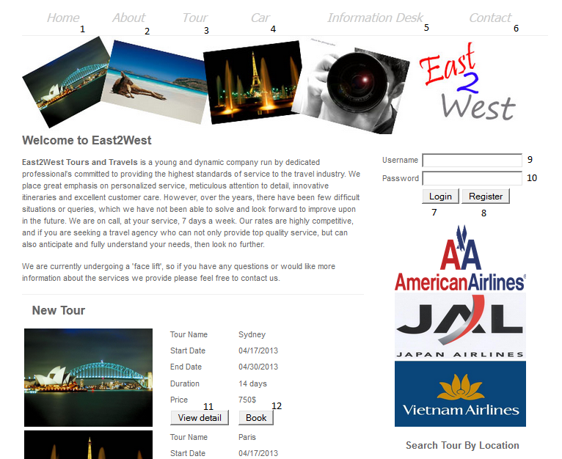

|  |  |  |  |  |  |  |
| --- | --- | --- | --- | --- | --- | --- |
| No | Name | Type | Validation | Event | Description | Status |
| 1 | linkHome | Link |  | Click | Redirect to Home Page |  |
| 2 | linkAbout | Link |  | Click | Redirect to About Page |  |
| 3 | linkTour | Link |  | Click | Redirect to Tour Page |  |
| 4 | linkCar | Link |  | Click | Redirect to  Car Page |  |
| 5 | linkInformationDesk | Link |  | Click | Redirect to Information Desk |  |
| 6 | linkContact | Link |  | Click | Redirect to Contact Page |  |
| 7 | btLogin | Button |  | Click | Login to system and redirect to Home Page |  |
| 8 | btRegister | Button |  | Click | Redirect to Register Page |  |
| 9 | txtUsername | Text field | Not null |  | Username |  |
| 10 | txtPassword | Text field | Not null |  | Password |  |
| 11 | btViewDetail | Button |  |  | Redirect to Tour/Car Detail Page |  |
| 12 | btBook | Button |  |  | Redirect to Tour Cart Page |  |

**2.Register Page**

The Guest can register an account by this page

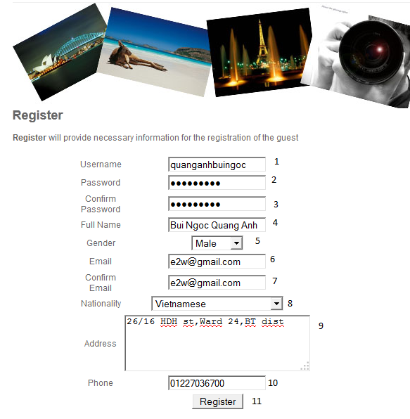

|  |  |  |  |  |  |  |
| --- | --- | --- | --- | --- | --- | --- |
| No | Name | Type | Validation | Event | Description | Status |
| 1 | txtUsername | Text field | Not null | Click | Username |  |
| 2 | txtPassword | Text field | Not null | Click | User’s Password |  |
| 3 | txtConfirmPassword | Text field | Same as txtPassword | Click | Confirm Password |  |
| 4 | txtFullName | Text field | Not null | Click | User’s full name |  |
| 5 | cbGender | Combo Box |  | Click | Gender selection |  |
| 6 | txtEmail | Text field | 0<length<=30  /.+@.+\.[a-z]+/ | Click | User’s email |  |
| 7 | txtConfirmEmail | Combo Box | Same as txtEmail | Click | Confirm email |  |
| 8 | cbNationality | Combox Box |  | Click | User’s Nationality |  |
| 9 | txtAddress | Text field | Not null | Click | User’s address |  |
| 10 | txtPhone | Text field | Not null |  | User’s phone |  |
| 11 | btRegister | Button |  |  | Register user with the system redirect to Home Page |  |

**3.Tour Page**

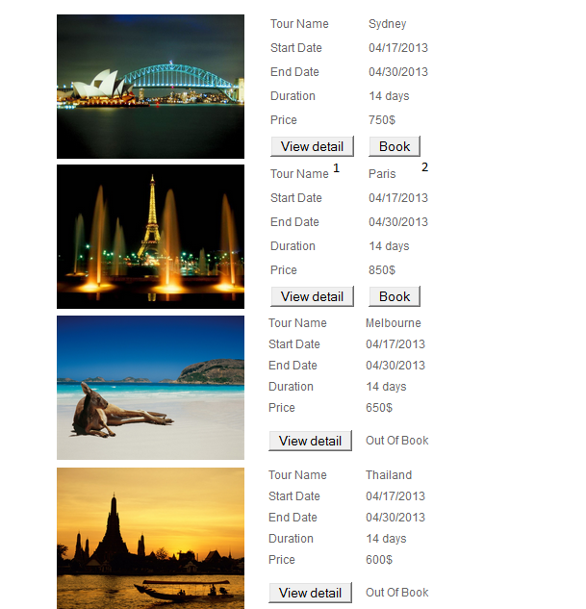

|  |  |  |  |  |  |  |
| --- | --- | --- | --- | --- | --- | --- |
| No | Name | Type | Validation | Event | Description | Status |
| 1 | btViewDetail | Button |  | Click |  | Redirect to Tour Detail Page |
| 2 | btBook | Button |  | Click |  | Redirect to Tour Cart Page |

**4.Tour Detail Page**

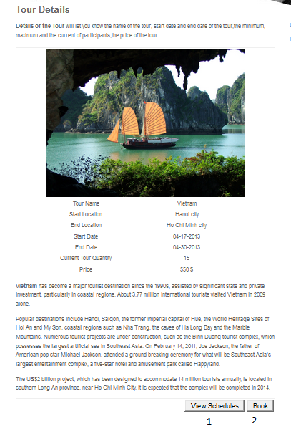

|  |  |  |  |  |  |  |
| --- | --- | --- | --- | --- | --- | --- |
| No | Name | Type | Validation | Event | Description | Status |
| 1 | btViewSchedules | Button |  | Click |  | Redirect to Tour Detail Page |
| 2 | btBook | Button |  | Click |  | Redirect to Tour Cart Page |

**5.Schedule Tour Page**

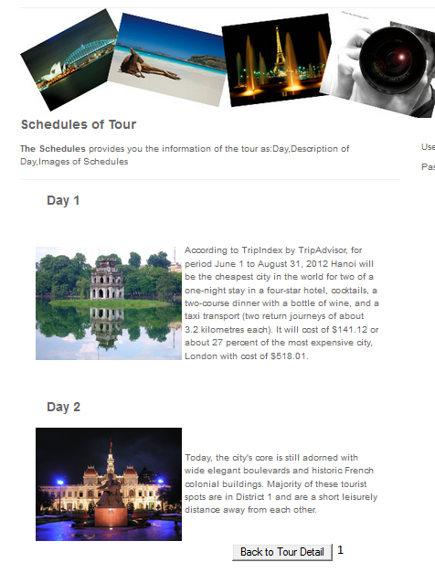d

|  |  |  |  |  |  |  |
| --- | --- | --- | --- | --- | --- | --- |
| No | Name | Type | Validation | Event | Description | Status |
| 1 | btBackToTourDetail | Button |  | Click |  | Redirect to Tour Detail Page |

**6.Tour Cart Page**

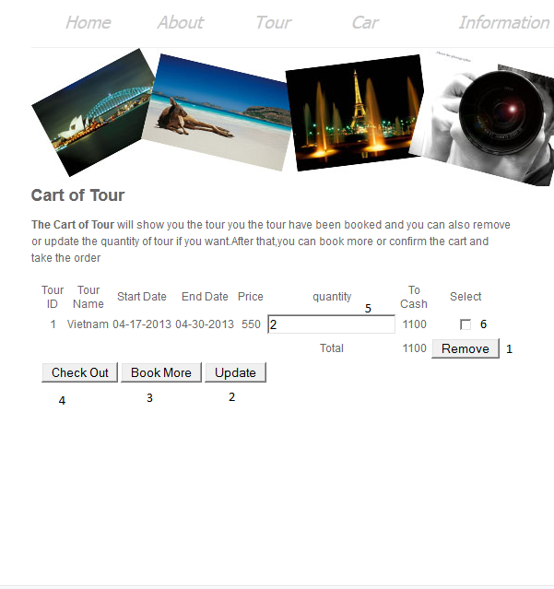

|  |  |  |  |  |  |  |
| --- | --- | --- | --- | --- | --- | --- |
| No | Name | Type | Validation | Event | Description | Status |
| 1 | btRemove | Button |  | Click |  | Remove current cart has been selected |
| 2 | btUpdate | Button |  | Click |  | Update all information of tour has been change in Cart |
| 3 | btBookMore | Button |  | Click |  | Redirect to Search Page if Customer want to book more tour |
| 4 | btCheckOut | Button |  | Click |  | Redirect to Confirm Cart Page to confirm the order |
| 5 | txtQuantity | Text field |  |  |  |  |

**7.Order Tour Page**

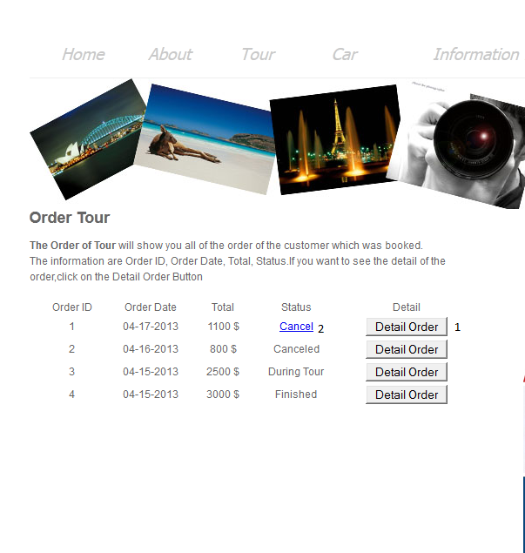

|  |  |  |  |  |  |  |
| --- | --- | --- | --- | --- | --- | --- |
| No | Name | Type | Validation | Event | Description | Status |
| 1 | btOrderDetail | Button |  | Click |  | Redirect to Order Detail Page |
| 2 | linkCancel | Link |  | Click |  | Confirm cancel tour.There are 3 status :  + Finished  + During Tour  +Canceled |

**8. Order**

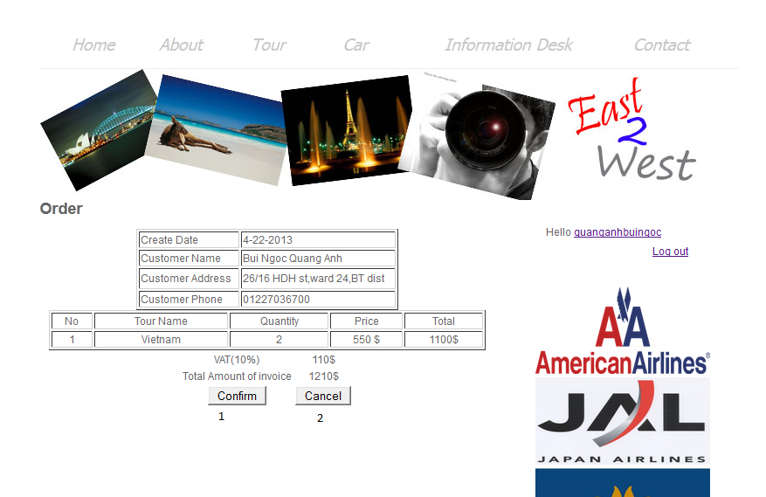

|  |  |  |  |  |  |  |
| --- | --- | --- | --- | --- | --- | --- |
| No | Name | Type | Validation | Event | Description | Status |
| 1 | btConfirm | Submit |  | Click |  | Confirm to system and insert to the order database |
| 2 | btCancel | Submit |  | Click |  | Redirect to Tour Cart Page |

**9.Order Cancel**

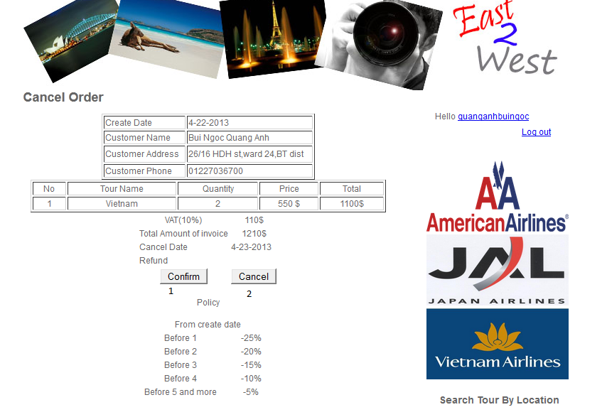

|  |  |  |  |  |  |  |
| --- | --- | --- | --- | --- | --- | --- |
| No | Name | Type | Validation | Event | Description | Status |
| 1 | btConfirm | Submit |  | Click |  | Confirm to system and cancel the order in database |
| 2 | btCancel | Submit |  | Click |  | Redirect to Order Tour Page |

**10.Customer Information**

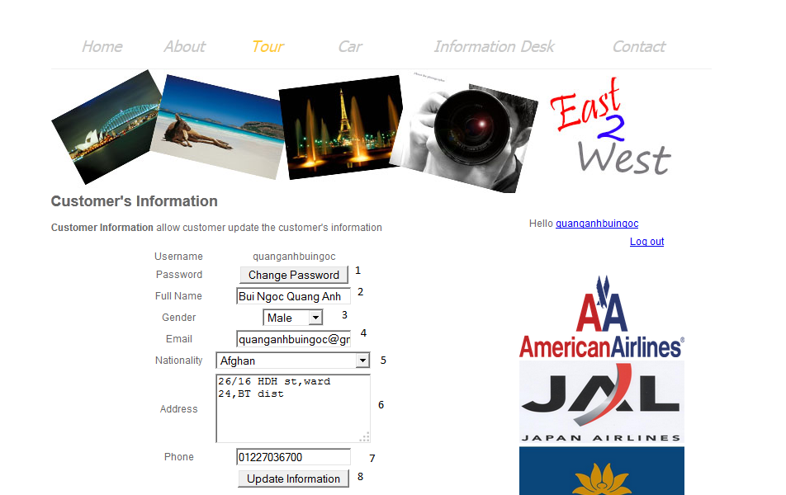

|  |  |  |  |  |  |  |
| --- | --- | --- | --- | --- | --- | --- |
| No | Name | Type | Validation | Event | Description | Status |
| 1 | btChangePassword | Button |  | Click |  | Redirect to Change Password Page |
| 2 | txtFullName | Text Field |  |  |  | Customer’s Full name |
| 3 | cbGender | Combo box |  |  |  | Customer’s Gender |
| 4 | txtEmail | Text Field |  |  |  | Customer’s Email |
| 5 | ddlNationality | Combo Box |  |  |  | Customer’s Nationality |
| 6 | txtAddress | Text Field |  |  |  | Customer’s Address |
| 7 | txtPhone | Text Field |  |  |  | Customer’s Phone |
| 8 | btUpdateInfo | Button |  | Click |  | System will update the customer’s information and redirect into Customer Information Page again |

**11.Update Password**

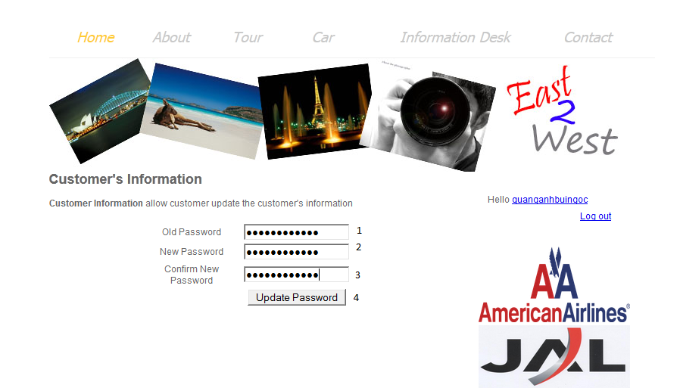

|  |  |  |  |  |  |  |
| --- | --- | --- | --- | --- | --- | --- |
| No | Name | Type | Validation | Event | Description | Status |
| 1 | txtOldPassword | Text field |  |  |  | Customer’s Old Password |
| 2 | txtNewPassword | Text field |  |  |  | Customer’s New Password |
| 3 | txtConfirmNewPassword | Text field |  |  |  | Confirm new Password |
| 4 | btUpdatePassword | Submit |  | Click |  | System update Customer’s Password |

**12.Flight Information**

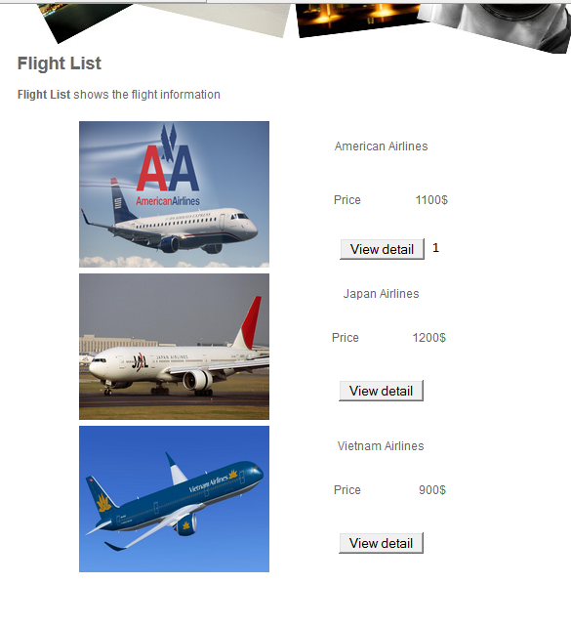

|  |  |  |  |  |  |  |
| --- | --- | --- | --- | --- | --- | --- |
| No | Name | Type | Validation | Event | Description | Status |
| 1 | btViewDetail | Submit |  | Click |  | Redirect to Flight Detail page |

**13.Flight Detail**

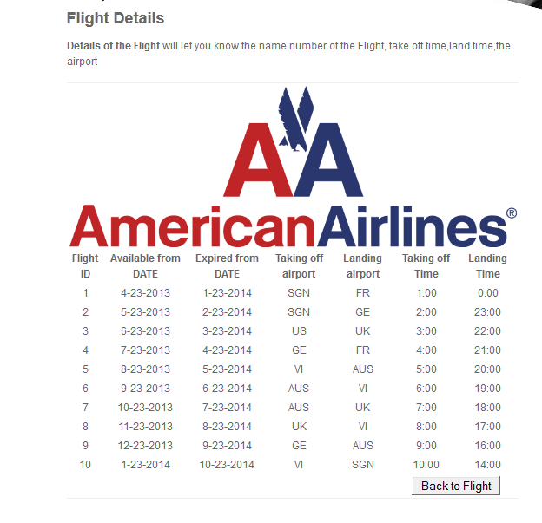

|  |  |  |  |  |  |  |
| --- | --- | --- | --- | --- | --- | --- |
| No | Name | Type | Validation | Event | Description | Status |
| 1 | btBackToFlight | Submit |  | Click |  | Redirect to Flight Information page |

**14.Report**

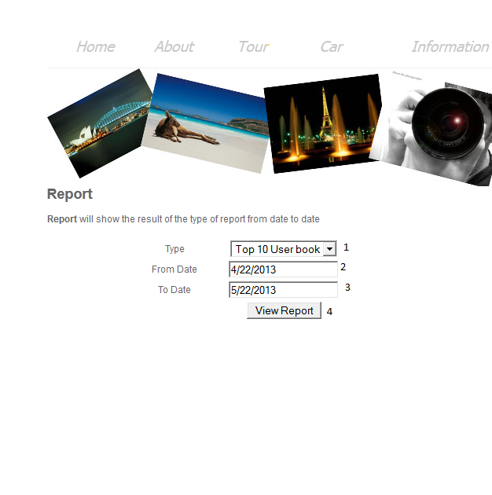

|  |  |  |  |  |  |  |
| --- | --- | --- | --- | --- | --- | --- |
| No | Name | Type | Validation | Event | Description | Status |
| 1 | cbType | Combox box |  |  |  |  |
| 2 | txtFromDate | DatePicker |  |  |  |  |
| 3 | txtToDate | DatePicker |  |  |  |  |
| 4 | btViewReport | Submit |  |  |  | Redirect to Report Result Page |

**15.Result Report Page**

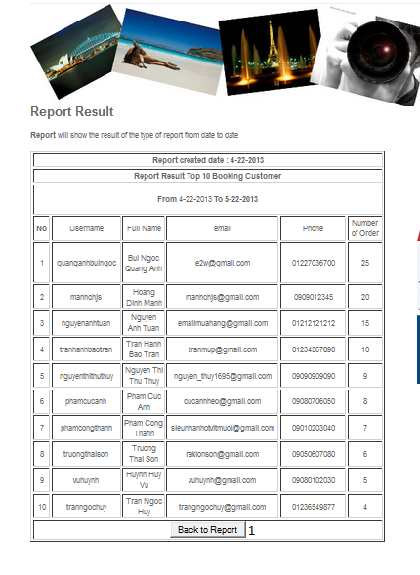

|  |  |  |  |  |  |  |
| --- | --- | --- | --- | --- | --- | --- |
| No | Name | Type | Validation | Event | Description | Status |
| 1 | btBackToReport | Submit |  | Click |  | Redirect to Report page |

**16. Car Search**

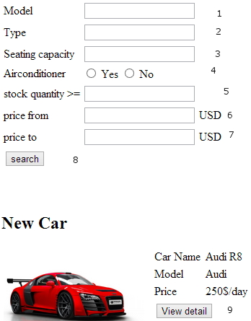

|  |  |  |  |  |  |  |
| --- | --- | --- | --- | --- | --- | --- |
| No | Name | Type | Validation | Event | Description | Status |
| 1 | $model | Text field |  |  | Model |  |
| 2 | $type | Text field |  |  | Type |  |
| 3 | $seat | Text field | Number only |  | Seating capacity |  |
| 4 | $airConditioner | Radio button |  |  | Air conditioner required |  |
| 5 | $stock | Text field | Number only |  | Quantity left more than |  |
| 6 | $from | Text field | Number only |  | From price |  |
| 7 | $to | Text field | Number only |  | To price |  |
| 8 | action | button |  | click | Search button |  |
| 9 | action | button |  | click | Description/view details button |  |

**17. Car view details/description**

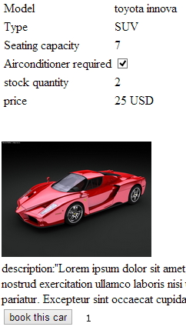

|  |  |  |  |  |  |  |
| --- | --- | --- | --- | --- | --- | --- |
| No | Name | Type | Validation | Event | Description | Status |
| 0 | Table car details | table |  |  | Display car's details include image and description |  |
| 1 | action | button |  | click | Book this car |  |

**18. Car booking**

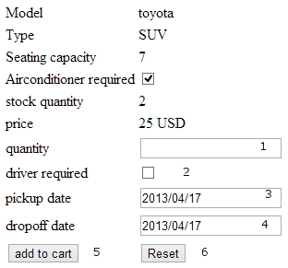

|  |  |  |  |  |  |  |
| --- | --- | --- | --- | --- | --- | --- |
| No | Name | Type | Validation | Event | Description | Status |
| 0 | Table car details | table |  |  | Display car's details for booking |  |
| 1 | $quantity | Text field | Number only, not null |  | quantity |  |
| 2 | $driver | checkbox |  |  | Driver required |  |
| 3 | $pickup | Text field | Date only, must be after today, not null |  | Pickup date |  |
| 4 | $dropoff | Text field | Date only, must not be before pickup date, not null |  | Dropoff date |  |
| 5 | action | button |  | click | Add to cart |  |
| 6 | reset | button |  | click | Reset form |  |

**19. Car shopping cart**

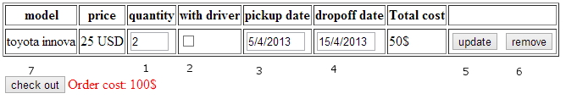

|  |  |  |  |  |  |  |
| --- | --- | --- | --- | --- | --- | --- |
| No | Name | Type | Validation | Event | Description | Status |
| 1 | $quantity | Text field | Number only, not null |  | quantity |  |
| 2 | $driver | checkbox |  |  | Driver required |  |
| 3 | $pickup | Text field | Date only, must be after today, not null |  | Pickup date |  |
| 4 | $dropoff | Text field | Date only, must not be before pickup date, not null |  | Dropoff date |  |
| 5 | action | button |  | click | Update cart item |  |
| 6 | action | button |  | click | Remove item from cart |  |
| 7 | action | button |  | click | Check out |  |

**20. Car check out**

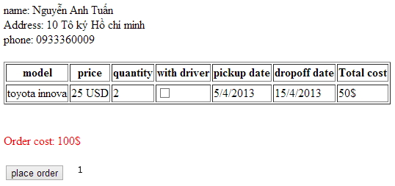

|  |  |  |  |  |  |  |
| --- | --- | --- | --- | --- | --- | --- |
| No | Name | Type | Validation | Event | Description | Status |
| 0 | Billing address table | table |  |  | Display customer's billing address, name and phone number |  |
| 0 | Order details table | Table |  |  | Display all order's item |  |
| 0 | Order cost | Text |  |  | Display order cost in red |  |
| 1 | action | button |  | click | Place order |  |

**21. Car order history**

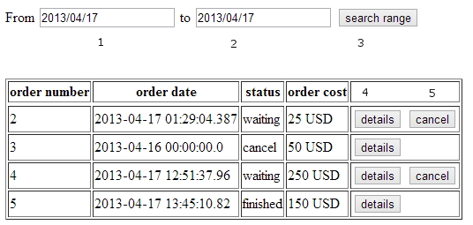

|  |  |  |  |  |  |  |
| --- | --- | --- | --- | --- | --- | --- |
| No | Name | Type | Validation | Event | Description | Status |
| 0 | Table order history | table |  |  | Display order that within the date range, or all order if range is null |  |
| 1 | $from | Text field | Date only |  | From date |  |
| 2 | $to | Text field | Date only |  | To date |  |
| 3 | action | button |  | click | Search date range |  |
| 4 | action | button |  | click | View order detail |  |
| 5 | action | button |  | click | Cancel waiting order |  |

**22. View car order details**

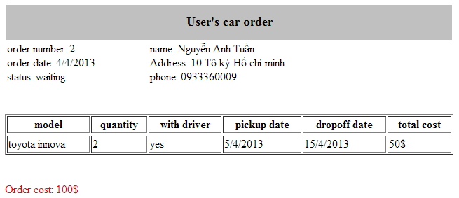

|  |  |  |  |  |  |  |
| --- | --- | --- | --- | --- | --- | --- |
| No | Name | Type | Validation | Event | Description | Status |
| 0 | Billing address and order detail table | table |  |  | Display customer's billing address, name ,phone number and order number, order date, order status |  |
| 0 | Order details table | Table |  |  | Display all order's item |  |
| 0 | Order cost | Text |  |  | Display order cost in red |  |

**23. Car admin add new**

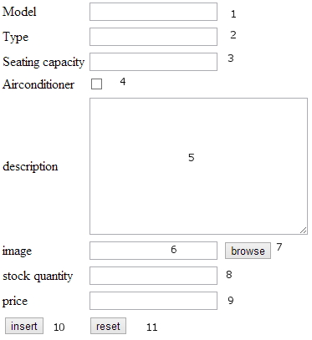

|  |  |  |  |  |  |  |
| --- | --- | --- | --- | --- | --- | --- |
| No | Name | Type | Validation | Event | Description | Status |
| 1 | $model | Text field | Not null |  | Model |  |
| 2 | $type | Text field | Not null |  | Type |  |
| 3 | $seat | Text field | Number only, not null |  | Seating capacity |  |
| 4 | $airConditioner | checkbox |  |  | Air conditioner required |  |
| 5 | $description | Text area | Not null |  | Description |  |
| 6 | $image | Text field | Not null |  | image |  |
| 7 | browse | button |  | click | Browse image to upload |  |
| 8 | $stock | Text field | Number only, not null |  | Quantity stock |  |
| 9 | $price | Text field | Number only, not null |  | price |  |
| 10 | action | button |  | click | insert button |  |
| 11 | reset | button |  | click | Reset form data |  |

**24. Car search admin**

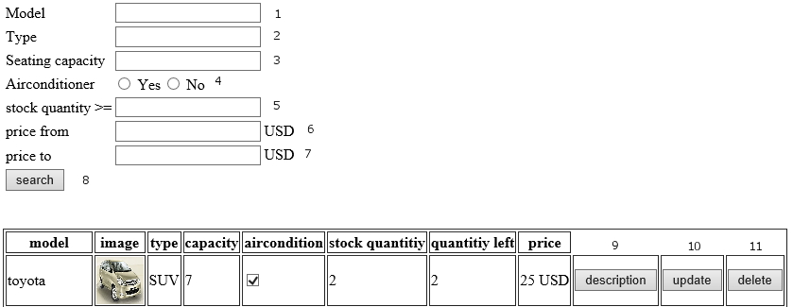

|  |  |  |  |  |  |  |
| --- | --- | --- | --- | --- | --- | --- |
| No | Name | Type | Validation | Event | Description | Status |
| 1 | $model | Text field |  |  | Model |  |
| 2 | $type | Text field |  |  | Type |  |
| 3 | $seat | Text field | Number only |  | Seating capacity |  |
| 4 | $airConditioner | Radio button |  |  | Air conditioner required |  |
| 5 | $stock | Text field | Number only |  | Quantity left more than |  |
| 6 | $from | Text field | Number only |  | From price |  |
| 7 | $to | Text field | Number only |  | To price |  |
| 8 | action | button |  | click | Search button |  |
| 9 | action | button |  | click | Description/view details button |  |
| 10 | action | Button |  | click | Redirect to car update page |  |
| 11 | action | button |  | click | Prompt for confirmation then disable car |  |

**25. Car admin view details/description**

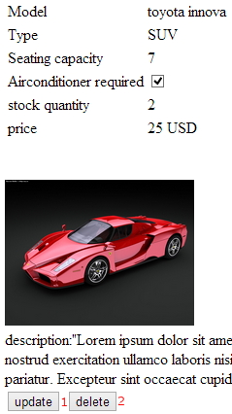

|  |  |  |  |  |  |  |
| --- | --- | --- | --- | --- | --- | --- |
| No | Name | Type | Validation | Event | Description | Status |
| 0 | Table car details | table |  |  | Display car's details include image and description |  |
| 1 | action | button |  | click | Redirect to car update page |  |
| 2 | action | button |  | click | Prompt for confirmation then disable car |  |

**26. Car admin update**

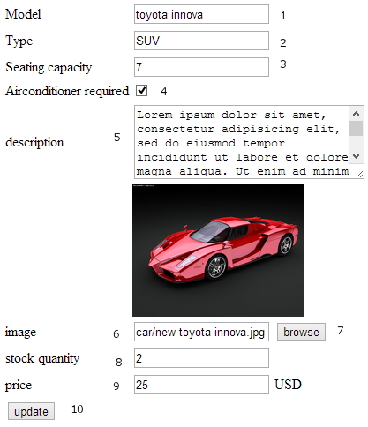

|  |  |  |  |  |  |  |
| --- | --- | --- | --- | --- | --- | --- |
| No | Name | Type | Validation | Event | Description | Status |
| 1 | $model | Text field | Not null |  | Model |  |
| 2 | $type | Text field | Not null |  | Type |  |
| 3 | $seat | Text field | Number only, not null |  | Seating capacity |  |
| 4 | $airConditioner | checkbox |  |  | Air conditioner required |  |
| 5 | $description | Text area | Not null |  | Description |  |
| 6 | $image | Text field | Not null |  | image |  |
| 7 | browse | button |  | click | Browse image to upload |  |
| 8 | $stock | Text field | Number only, not null |  | Quantity stock |  |
| 9 | $price | Text field | Number only, not null |  | price |  |
| 10 | action | button |  | click | Update car details |  |

**27. Report search page**



|  |  |  |  |  |  |  |
| --- | --- | --- | --- | --- | --- | --- |
| No | Name | Type | Validation | Event | Description | Status |
| 1 | $from | Text field | Date only |  | From date |  |
| 2 | $to | Text field | Date only |  | To date |  |
| 3 | action | button |  | click | Search report |  |

**28 Report Car show page**

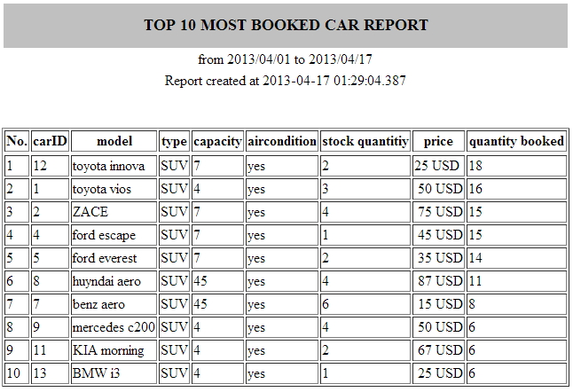

|  |  |  |  |  |  |  |
| --- | --- | --- | --- | --- | --- | --- |
| No | Name | Type | Validation | Event | Description | Status |
| 0 | Report table | table |  |  | Show top 10 car in that date range in a printable format |  |

**29. Create Tour**

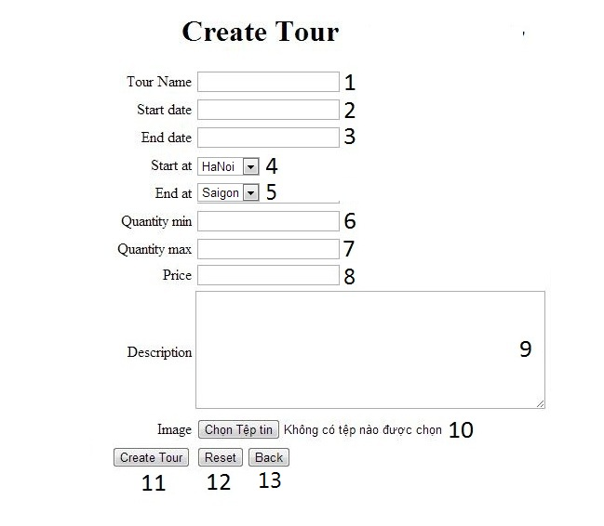

|  |  |  |  |  |  |  |
| --- | --- | --- | --- | --- | --- | --- |
| No. | Name | Type | Validation | Event | Description | Status |
| 1 | txttourname | Text field | 6<=length<=30  Not exist in the database |  | Tour Name |  |
| 2 | txtstartdate | Text field | Not null |  | Start date |  |
| 3 | txtenddate | Text field | Not null |  | End date |  |
| 4 | txtstartat | Combo box | Not null |  | Start at |  |
| 5 | txtendat | Combo box | Not null |  | End at |  |
| 6 | txtquantitymin | Text field | Not null |  | Quantity min of tour |  |
| 7 | txtquantitymax | Text field | Not null |  | Quantity max of tour |  |
| 8 | txtprice | Text field | Not null |  | Price of tour |  |
| 9 | txtdescription | Text field | Not null |  | Description of tour |  |
| 10 | urlimage | Text field | Not null | Click | Image |  |
| 11 | btncreate | Upload field |  | Click | Create button |  |
| 12 | btnreset | Button |  | Click | Reset button |  |
| 13 | btnback | Button |  | Click | Back button |  |

**30. Update Tour**

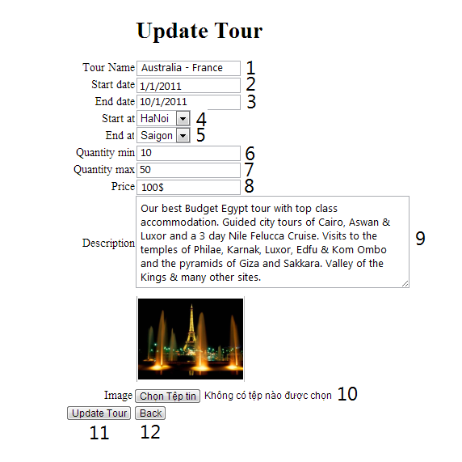

|  |  |  |  |  |  |  |
| --- | --- | --- | --- | --- | --- | --- |
| No. | Name | Type | Validation | Event | Description | Status |
| 1 | txttourname | Text field | 6<=length<=30  Not exist in the database |  | Tour Name |  |
| 2 | txtstartdate | Text field | Not null |  | Start date |  |
| 3 | txtenddate | Text field | Not null |  | End date |  |
| 4 | txtstartat | Combo box | Not null |  | Start at |  |
| 5 | txtendat | Combo box | Not null |  | End at |  |
| 6 | txtquantitymin | Text field | Not null |  | Quantity min of tour |  |
| 7 | txtquantitymax | Text field | Not null |  | Quantity max of tour |  |
| 8 | txtprice | Text field | Not null |  | Price of tour |  |
| 9 | txtdescription | Text field | Not null |  | Description of tour |  |
| 10 | urlimage | Text field | Not null | Click | Image |  |
| 11 | btncreate | Upload field |  | Click | Create button |  |
| 12 | btnreset | Button |  | Click | Reset button |  |
| 13 | btnback | Button |  | Click | Back button |  |

**31. Delete Tour**

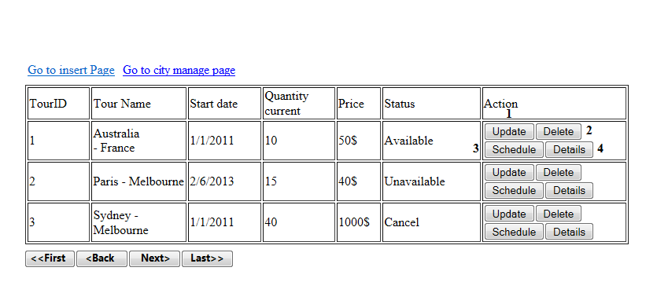

|  |  |  |  |  |  |  |
| --- | --- | --- | --- | --- | --- | --- |
| No. | Name | Type | Validation | Event | Description | Status |
| 1 | btnupdate | button |  | Click | Update button |  |
| 2 | btndelete | button |  | Click | Delete button |  |
| 3 | btndetails | button |  | Click | Details button |  |
| 4 | btnschedule | button |  | Click | Schedule button |  |

**32. Add Schedule**

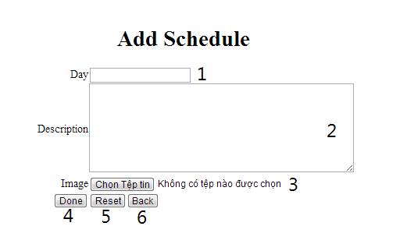

|  |  |  |  |  |  |  |
| --- | --- | --- | --- | --- | --- | --- |
| No. | Name | Type | Validation | Event | Description | Status |
| 1 | txtday | Text field |  |  | Day number |  |
| 2 | txtareadescription | Text field |  |  | Description of schedule |  |
| 3 | urlimage | Text field |  | Click | Image of schedule |  |
| 4 | btndone | Button |  | Click | Done button |  |
| 5 | btnreset | Button |  | Click | Reset button |  |
| 6 | btnback | Button |  | Click | Back button |  |

**33. Update Schedule**

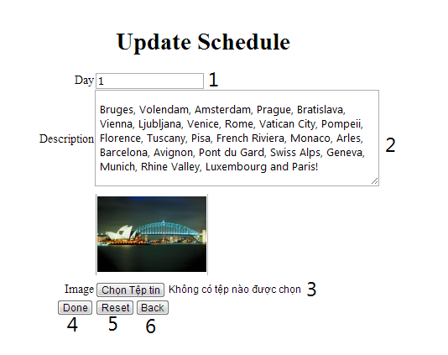

|  |  |  |  |  |  |  |
| --- | --- | --- | --- | --- | --- | --- |
| No. | Name | Type | Validation | Event | Description | Status |
| 1 | txtday | Text field |  |  | Day number |  |
| 2 | txtareadescription | Text field |  |  | Description of schedule |  |
| 3 | urlimage | Text field |  | Click | Image of schedule |  |
| 4 | btndone | Button |  | Click | Done button |  |
| 5 | btnreset | Button |  | Click | Reset button |  |
| 6 | btnback | Button |  | Click | Back button |  |

**34.Delete Schedule**

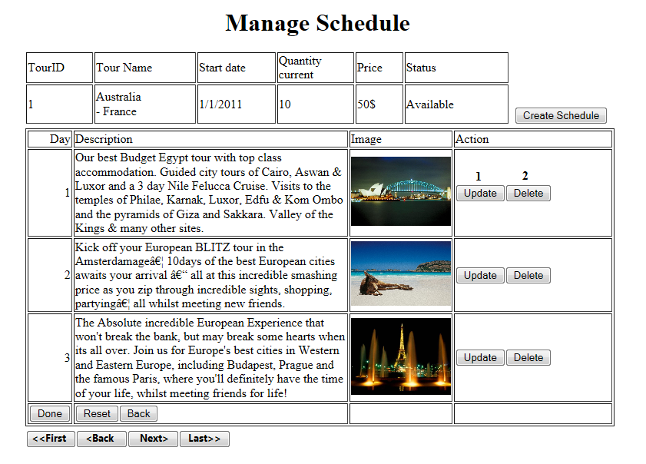

|  |  |  |  |  |  |  |
| --- | --- | --- | --- | --- | --- | --- |
| No. | Name | Type | Validation | Event | Description | Status |
| 1 | btnupdate | Button |  | Click | Update button |  |
| 2 | btndelete | Button |  | Click | Delete button |  |
| 3 | btndone | Button |  | Click | Done button |  |
| 4 | btnreset | Button |  | Click | Reset button |  |
| 5 | btnback | Button |  | Click | Back button |  |

**35. Report 10 most hot tour**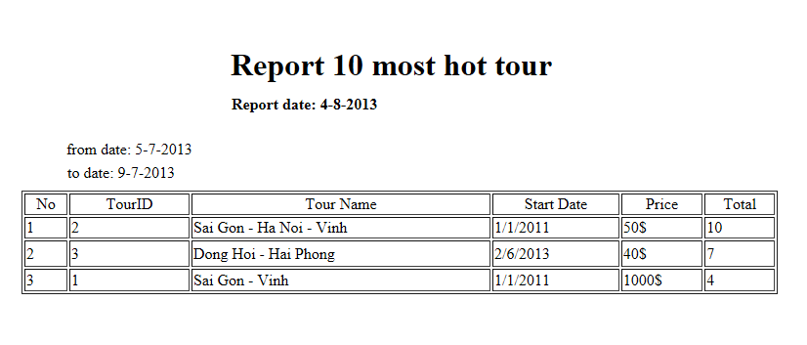

**36. Hotel overview**

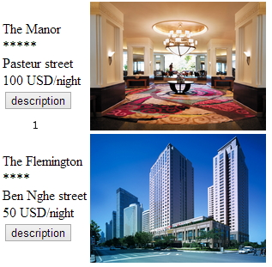

|  |  |  |  |  |  |  |
| --- | --- | --- | --- | --- | --- | --- |
| No. | Name | Type | Validation | Event | Description | Status |
| 0 | Hotel overview table | table |  |  | Table list all hotel |  |
| 1 | action | button |  | click | View description button |  |

**37. Hotel detail**

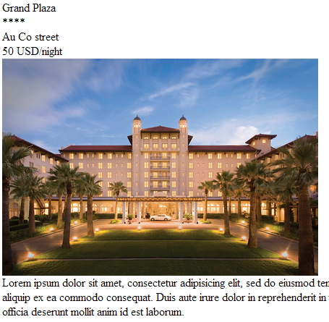

|  |  |  |  |  |  |  |
| --- | --- | --- | --- | --- | --- | --- |
| No. | Name | Type | Validation | Event | Description | Status |
| 0 | Hotel detail | text |  |  | Hotel detail |  |

**38. Add City**

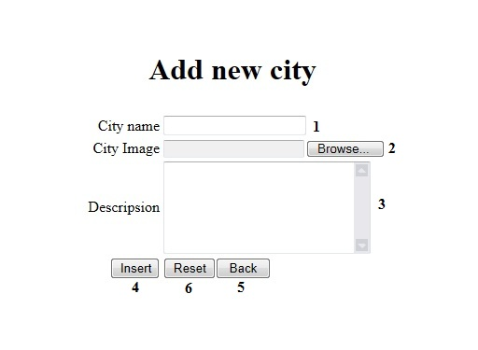

|  |  |  |  |  |  |  |
| --- | --- | --- | --- | --- | --- | --- |
| No. | Name | Type | Validation | Event | Description | Status |
| 1 | txtcityname | Text field |  |  | City name |  |
| 2 | urlimage | Text field |  |  | Image of city |  |
| 3 | txtdescription | Text field |  |  | Description of city |  |
| 4 | btninsert | Button |  | Click | Insert button |  |
| 5 | btnback | Button |  | Click | Back button |  |
| 6 | Btnreset | Button |  | Click | Reset button |  |

**39. Update City**

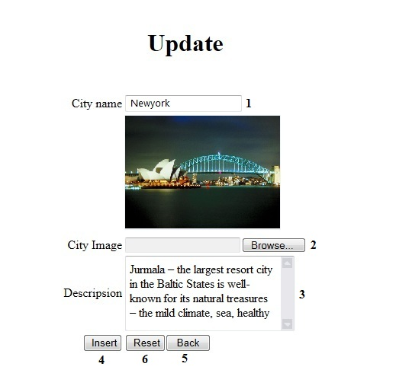

|  |  |  |  |  |  |  |
| --- | --- | --- | --- | --- | --- | --- |
| No. | Name | Type | Validation | Event | Description | Status |
| 1 | txtcityname | Text field |  |  | City name |  |
| 2 | urlimage | Text field |  |  | Image of city |  |
| 3 | txtdescription | Text field |  |  | Description of city |  |
| 4 | btninsert | Button |  | Click | Insert button |  |
| 5 | btnback | Button |  | Click | Back button |  |
| 6 | Btnreset | Button |  | Click | Reset button |  |

**40. Delete City**

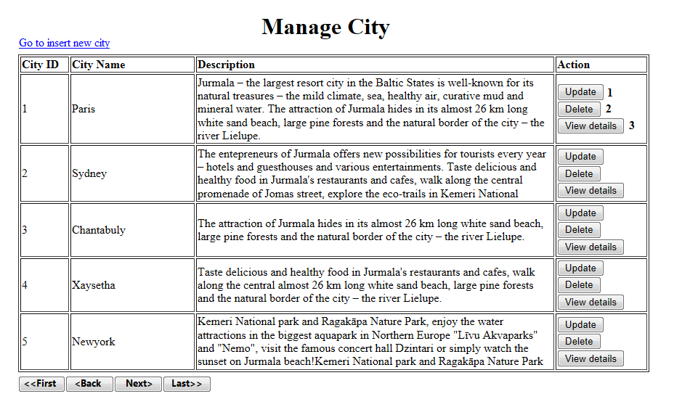

|  |  |  |  |  |  |  |
| --- | --- | --- | --- | --- | --- | --- |
| No. | Name | Type | Validation | Event | Description | Status |
| 1 | btnupdate | Button |  | Click | Update button |  |
| 2 | btndelete | Button |  | Click | Delete button |  |
| 3 | btnviewdetails | Button |  | Click | Done button |  |

|  |  |  |
| --- | --- | --- |
|  | **Prepared by (Student)** | **Approved by (Faculty)** |
| **Signature** | Team leader  **Bui Ngoc Quang Anh** | **Pham Cong Thanh** |
| **Date** |  |  |